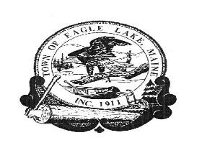
TOWN OF EAGLE LAKE

BOARD OF SELECTMEN MEETING
November 18, 2020
5:30 P.M.
****************************************
AGENDA
- CALL TO ORDER: TIME 5:30 P.M.

2. WELCOME NEW SELECTMAN BRIAN DEVOE

3. PUBLIC HEARING FOR A LIQUOR LICENSE RENEWAL FOR AMERICAN
LEGION SMART / SOUCY POST #176

4. VOTE ON LIQUOR LICENSE RENEWAL

5. PUBLIC COMMENT

6. TOWN MANAGER’S REPORT
UPDATES
a. Micro Loan
b. Pond Brook Estates
c. Roads
d. NASWA
e. Eagle Lake Fire Department
f. Town Facilities
g. Junk Yard Update
h. Town Forest Harvest Update

7. MONTHLY FINANCIALS – October 2020
Review monthly financials for October
- Bank Reconciliations
- Pond Brook Bank Reconciliation
- Sample Check Audit
- Sign Warrants
- Microloan

8. APPROVE THE MINUTES OF OCTOBER 21, 2020 SELECTMEN’S MEETING
APPROVE THE MINUTES OF OCTOBER 28, 2020 SELECTMEN’S MEETING

9. REVIEW AND CONSIDER BIDS FOR A NEW PUMPER/TANKER

10. SPIRIT OF AMERICA AWARD

11. LETTERS OF APPRECIATION

12. WINTER RECREATION ACTIVITIES FOLLOW-UP

13. OTHER BUSINESS:
14. ADJOURN

