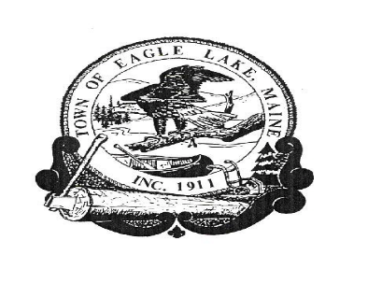
TOWN OF EAGLE LAKET
BOARD OF SELECTMEN’S MEETING
November 5, 2019

1. The meeting was called to order by Board Chair, Michelle Raymond at 5:30 P.M.
The Board members present included: Michelle Raymond, Wendy Dube, Louise
Fournier, Arthur Carroll and Jennifer Dube.
Others in attendance were: John Sutherland, Town Manager;

2. EXECUTIVE SESSION: 1 M.R.S.A. § 405 (6) (F) Confidential Records
Northern Aroostook Solid Waste Association (NASWA)

Moved by Wendy Dube to go into Executive Session, seconded by Arthur Carroll.
Vote: Unanimously in favor.
In: 5:30 p.m.
Out: 7:15 p.m.

No Motion was made as a result of the Executive Session

3. Adjourn
Moved by Wendy Dube to adjourn at 7:15, seconded by Louise Fournier
Vote: Unanimously in favor.

Meeting adjourned at 7:15

