COVID -19 Resources

https://www.cdc.gov/coronavirus/2019-nCoV/index.html

Response from Governor Mills
https://www.maine.gov/governor/mills/covid-19

Division of Disease Surveillance
Maine Center for Disease Control & Prevention
A Division of the Maine Department of Health and Human Services
http://www.maine.gov/dhhs/mecdc/infectious-disease/epi/airborne/coronavirus.shtml

Local Health Department

Maine DHS/Fort Kent
137 Market St
Fort Kent, ME 04743-1452
Phone: (207) 834-7770

For Individuals who employment status suffered or who are quarantined.
Emergency Bill Offers New Flexibility in Maine’s Unemployment Insurance Program
AUGUSTA - Maine Department of Labor (Department) will begin to implement new flexible unemployment insurance (UI) measures that will benefit both workers and businesses thanks to emergency legislation from Governor Mills that was enacted by the Legislature Tuesday night. These temporary measures will help relieve the financial burden of temporary layoffs, isolation, and medically-necessary quarantine by making unemployment benefits available to individuals whose employment has been impacted by COVID-19.
“If workers do not have access to employer-provided paid time off or leave, this legislation can provide an important partial wage replacement,” Labor Commissioner Laura Fortman said. “This helps not only the individual but allows employers to retain their workforce and stabilize local economies.”
Individuals who would otherwise be able and available to work and who maintain contact with their employer may now be eligible for UI. Anyone who has filed for unemployment benefits on or after March 15th will be reviewed under these new temporary measures. The legislation temporarily revises eligibility requirement to provide unemployment coverage in situations not typically covered, such as:
- An employer temporarily ceases operation due to COVID-19
- An individual is quarantined with the expectation of returning to work once the quarantine is over
- An individual must take a leave of absence to care for a dependent who is affected
The legislation is not intended to provide sick leave or short-term disability payments.
The legislation waives the work search requirement for individuals still connected to their employer and waives the one-week waiting period so that benefits will be available sooner. Important for businesses, any benefits paid under these provisions would not affect the employer’s experience rating record.
UI Claims can be filed online or by phone at: https://reemployme.maine.gov/ or 1-800-593-7660. The Department provides unemployment filing free of charge; individuals should never be asked to pay a fee to file a claim.
For more information and resources, visit the Department’s COVID-19 page: https://www.maine.gov/labor/covid19/, and follow the Maine Department of Labor on Facebook @MElabor and Twitter @maine_labor.

Frequently Asked Questions
Read the full List of Frequently Asked Questions (PDF).

What is COVID-19?
COVID-19 is a novel (new) coronavirus which was first detected in December 2019 in Wuhan City, Hubei Province, China and has now been detected in other countries, including the United States.
For some, the respiratory virus causes mild symptoms like the common cold or influenza (flu), for others it can cause severe pneumonia that requires medical care or hospitalization.
The virus is named "SARS-CoV-2" and the disease it causes is named "coronavirus disease 2019" (abbreviated "COVID-19").

What are the Symptoms?
Symptoms of COVID-19 may include:
- Fever
- Cough
- Difficulty breathing
- Sore throat (in some patients)
Symptoms may appear 2-14 days after exposure.
Most patients experience mild symptoms and can recuperate at home, but others, particularly those with underlying medical conditions, may experience more severe respiratory illness.

How does it spread?
The virus appears to spread in similar ways to influenza (flu) and the common cold. This may include spreading through:
- The air by coughing and sneezing
- Close personal contact, such as touching or shaking hands
- Touching an object or surface with the virus on it, then touching your mouth, nose, or eyes
The virus can spread from person-to-person and in some locations there is apparent community spread, meaning some people are infected and are not sure how or where they became infected.

How can I help to prevent the spread?
There are simple steps you can take to reduce the possible spread of COVID-19 and other illnesses such as influenza and the common cold:
- Wash your hands often with soap and water for at least 20 seconds or use alcohol-based hand sanitizer
- Avoid close contact with people who are sick
- Avoid touching your eyes, nose, and mouth with unwashed hands
- Stay home while you're sick and avoid close contact with others
Currently there is no vaccine available to prevent the spread of COVID-19.

What should I do if I have symptoms?
Call ahead to a health care professional if you develop a fever and symptoms of respiratory illness, such as cough or difficulty breathing. Tell your health care professional about any recent travel or contact with other COVID-19 cases. Your healthcare professional will work with Maine CDC to determine if you need to be tested for COVID-19. More information is available on the U.S. CDC's What You Should Know page.

What is the situation in the U.S.?
For the general American public, who are unlikely to be exposed to this virus at this time, the immediate health risk from COVID-19 is considered low.
- People in communities where ongoing community spread with the virus that causes COVID-19 has been reported are at elevated though still relatively low risk of exposure.
- Health care workers caring for patients with COVID-19 are at elevated risk of exposure.
- Close contacts of persons with COVID-19 also are at elevated risk of exposure.
- Travelers returning from affected international locations where community spread is occurring also are at elevated risk of exposure.

Maine DHHS Press / News Release

211 now available to answer general questions about COVID-19
AUGUSTA – The Maine Center for Disease Control and Prevention (Maine CDC) and 211 Maine announced today a new option for Mainers to get answers to questions about the 2019 novel coronavirus (COVID-19) at any time. This service is available by dialing 211 (or 1-866-811-5695), texting your ZIP code to 898-211, or emailing info@211maine.org.
Maine has confirmed cases or presumptive positive tests for COVID-19. Maine CDC will inform the public if positive tests are confirmed and will offer regular updates on testing recommendations. The number of COVID-19 tests for Maine people will be updated daily Monday through Friday on Maine CDC's coronavirus webpage.
211 Maine is a free, confidential information and referral service that connects people of all ages across Maine to local services. Maine CDC worked closely with 211 Maine to incorporate answers to general questions about COVID-19 to the 211 resource. Calls, texts, and emails to 211 are answered 24/7 by a person here in the state.
211 Maine is equipped to answer general questions about the 2019 novel coronavirus, including how Maine people can best protect themselves, options for testing, and travel considerations. Anyone looking for specific medical advice regarding symptoms they may be experiencing is strongly urged to call their medical provider, an urgent care center, or 911, depending on the severity of their symptoms.
Symptoms of COVID-19 include fever, shortness of breath, and lower respiratory distress. Health care providers will make the initial determination on whether COVID-19 testing is advisable. In cases where it is, medical providers will alert the Maine CDC to coordinate testing. As appropriate, health providers will take samples and submit them to Maine CDC.
The best thing that Maine people can do to protect their health is to take the same preventive measures that help to avoid catching a cold: Wash your hands often. Cover coughs and sneezes. Stay home if you are sick.
Maine CDC continues comprehensive planning to ensure Maine is ready should the virus affect people here. Governor Janet Mills has convened a Coronavirus Response Team, led by Maine CDC Director Nirav Shah, charged with coordinating State government's response across departments and local agencies and health authorities to the potential spread of COVID-19.
For more information Contact 211 Maine for answers to frequently asked questions on COVID-19:
- Dial 211(or 1-866-811-5695)
- Text your ZIP code to 898-211
- Email info@211maine.org
- 211 is TTY and Video Relay accessible if calling from Maine
- Visit www.maine.gov/dhhs/coronavirus.

What To Do if You Are Sick
Related Pages
phone icon
Call your doctor: If you think you have been exposed to COVID-19 and develop a fever and symptoms, such as cough or difficulty breathing, call your healthcare provider for medical advice.
Printer friendly versionpdf icon

Steps to help prevent the spread of COVID-19 if you are sick
Follow the steps below: If you are sick with COVID-19 or think you might have it, follow the steps below to help protect other people in your home and community.
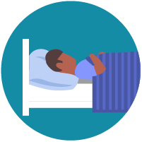
Stay home except to get medical care
- Stay home: People who are mildly ill with COVID-19 are able to recover at home. Do not leave, except to get medical care. Do not visit public areas.
- Stay in touch with your doctor. Call before you get medical care. Be sure to get care if you feel worse or you think it is an emergency.
- Avoid public transportation: Avoid using public transportation, ride-sharing, or taxis.
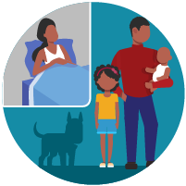
Separate yourself from other people in your home, this is known as home isolation
- Stay away from others: As much as possible, you should stay in a specific “sick room” and away from other people in your home. Use a separate bathroom, if available.
- Limit contact with pets & animals: You should restrict contact with pets and other animals, just like you would around other people.
  - Although there have not been reports of pets or other animals becoming sick with COVID-19, it is still recommended that people with the virus limit contact with animals until more information is known.
  - When possible, have another member of your household care for your animals while you are sick with COVID-19. If you must care for your pet or be around animals while you are sick, wash your hands before and after you interact with them. See COVID-19 and Animals for more information.
If someone in your home is sick
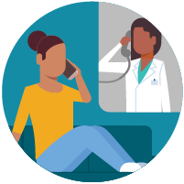
Call ahead before visiting your doctor
- Call ahead: If you have a medical appointment, call your doctor’s office or emergency department, and tell them you have or may have COVID-19. This will help the office protect themselves and other patients.
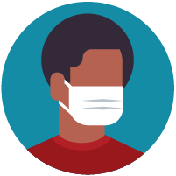
Wear a facemask if you are sick
- If you are sick: You should wear a facemask when you are around other people and before you enter a healthcare provider’s office.
- If you are caring for others: If the person who is sick is not able to wear a facemask (for example, because it causes trouble breathing), then people who live in the home should stay in a different room. When caregivers enter the room of the sick person, they should wear a facemask. Visitors, other than caregivers, are not recommended.
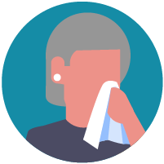
Cover your coughs and sneezes
- Cover: Cover your mouth and nose with a tissue when you cough or sneeze.
- Dispose: Throw used tissues in a lined trash can.
- Wash hands: Immediately wash your hands with soap and water for at least 20 seconds. If soap and water are not available, clean your hands with an alcohol-based hand sanitizer that contains at least 60% alcohol.
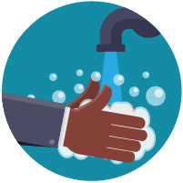
Clean your hands often
- Wash hands: Wash your hands often with soap and water for at least 20 seconds. This is especially important after blowing your nose, coughing, or sneezing; going to the bathroom; and before eating or preparing food.
- Hand sanitizer: If soap and water are not available, use an alcohol-based hand sanitizer with at least 60% alcohol, covering all surfaces of your hands and rubbing them together until they feel dry.
- Soap and water: Soap and water are the best option, especially if hands are visibly dirty.
- Avoid touching: Avoid touching your eyes, nose, and mouth with unwashed hands.
Handwashing tips
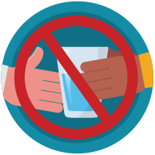
Avoid sharing personal household items
- Do not share: Do not share dishes, drinking glasses, cups, eating utensils, towels, or bedding with other people in your home.
- Wash thoroughly after use: After using these items, wash them thoroughly with soap and water or put in the dishwasher.
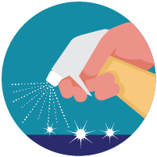
Clean all “high-touch” surfaces everyday
Clean high-touch surfaces in your isolation area (“sick room” and bathroom) every day; let a caregiver clean and disinfect high-touch surfaces in other areas of the home.
- Clean and disinfect: Routinely clean high-touch surfaces in your “sick room” and bathroom. Let someone else clean and disinfect surfaces in common areas, but not your bedroom and bathroom.

  - If a caregiver or other person needs to clean and disinfect a sick person’s bedroom or bathroom, they should do so on an as-needed basis. The caregiver/other person should wear a mask and wait as long as possible after the sick person has used the bathroom.
High-touch surfaces include phones, remote controls, counters, tabletops, doorknobs, bathroom fixtures, toilets, keyboards, tablets, and bedside tables.
- Clean and disinfect areas that may have blood, stool, or body fluids on them.
- Household cleaners and disinfectants: Clean the area or item with soap and water or another detergent if it is dirty. Then, use a household disinfectant.

  - Be sure to follow the instructions on the label to ensure safe and effective use of the product. Many products recommend keeping the surface wet for several minutes to ensure germs are killed. Many also recommend precautions such as wearing gloves and making sure you have good ventilation during use of the product.
  - Most EPA-registered household disinfectants should be effective. A full list of disinfectants can be found hereexternal icon.
Complete disinfection guidance
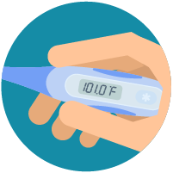
Monitor your symptoms
- Seek medical attention, but call first: Seek medical care right away if your illness is worsening (for example, if you have difficulty breathing).
  - Call your doctor before going in: Before going to the doctor’s office or emergency room, call ahead and tell them your symptoms. They will tell you what to do.
- Wear a facemask: If possible, put on a facemask before you enter the building. If you can’t put on a facemask, try to keep a safe distance from other people (at least 6 feet away). This will help protect the people in the office or waiting room.
- Follow care instructions from your healthcare provider and local health department: Your local health authorities will give instructions on checking your symptoms and reporting information.
If you develop emergency warning signs for COVID-19 get medical attention immediately. Emergency warning signs include*:
- Difficulty breathing or shortness of breath
- Persistent pain or pressure in the chest
- New confusion or inability to arouse
- Bluish lips or face
*This list is not all inclusive. Please consult your medical provider for any other symptoms that are severe or concerning.

alert icon
Call 911 if you have a medical emergency: If you have a medical emergency and need to call 911, notify the operator that you have or think you might have, COVID-19. If possible, put on a facemask before medical help arrives.
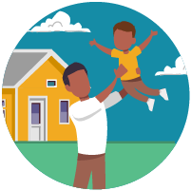
How to discontinue home isolation
- People with COVID-19 who have stayed home (home isolated) can stop home isolation under the following conditions:
  - If you will not have a test to determine if you are still contagious, you can leave home after these three things have happened:

    - You have had no fever for at least 72 hours (that is three full days of no fever without the use medicine that reduces fevers)
AND
    - other symptoms have improved (for example, when your cough or shortness of breath have improved)
AND
    - at least 7 days have passed since your symptoms first appeared
  - If you will be tested to determine if you are still contagious, you can leave home after these three things have happened:
    - You no longer have a fever (without the use medicine that reduces fevers)
AND
    - other symptoms have improved (for example, when your cough or shortness of breath have improved)
AND
you received two negative tests in a row, 24 hours apart. Your doctor will follow CDC guidelines.
In all cases, follow the guidance of your healthcare provider and local health department. The decision to stop home isolation should be made in consultation with your healthcare provider and state and local health departments. Local decisions depend on local circumstances

