Town of Eagle Lake

Municipal Report

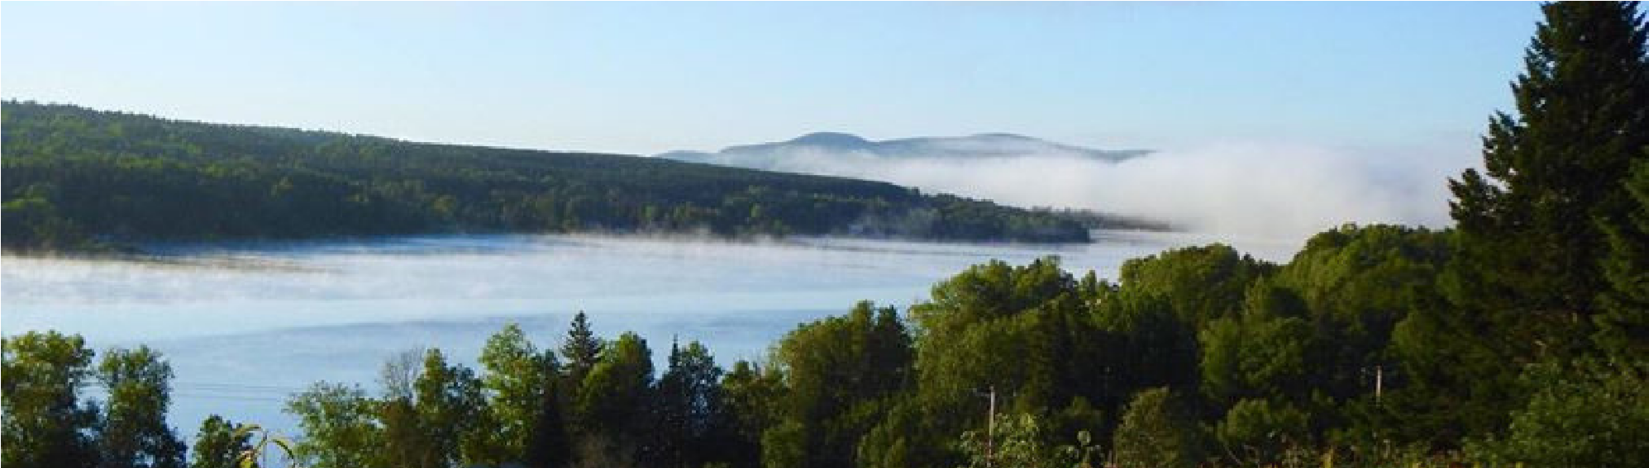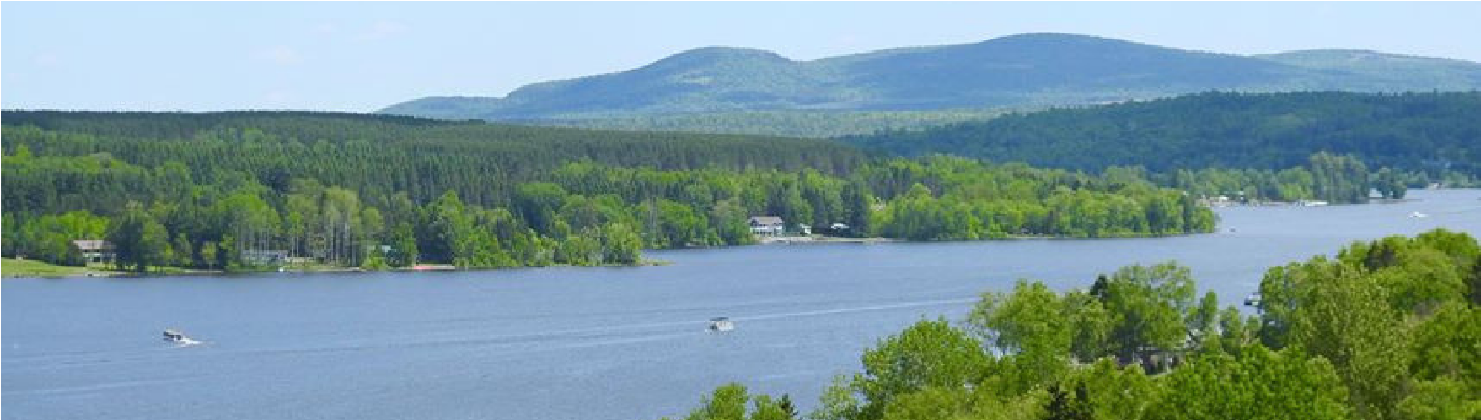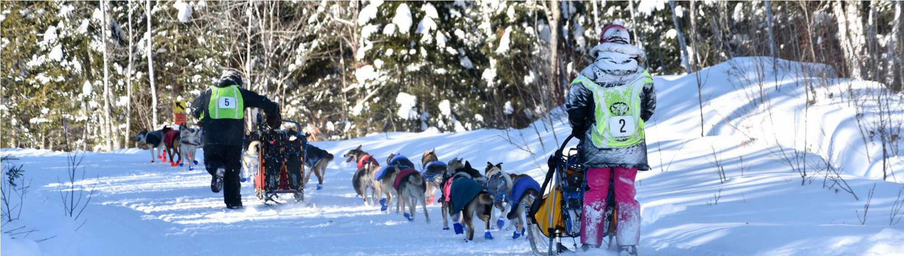

2018-2019

67th ANNUAL REPORT

OF THE MUNICIPAL OFFICERS OF THE
TOWN OF EAGLE LAKE, MAINE

FOR THE FISCAL YEAR ENDING JUNE 30, 2019

POPULATION 864 (2010 CENSUS)

INCORPORATED MARCH 16, 1911

TOWN MEETING FORM OF GOVERNMENT 1944 JOHN SUTHERLAND, TOWN MANAGER

Page 1
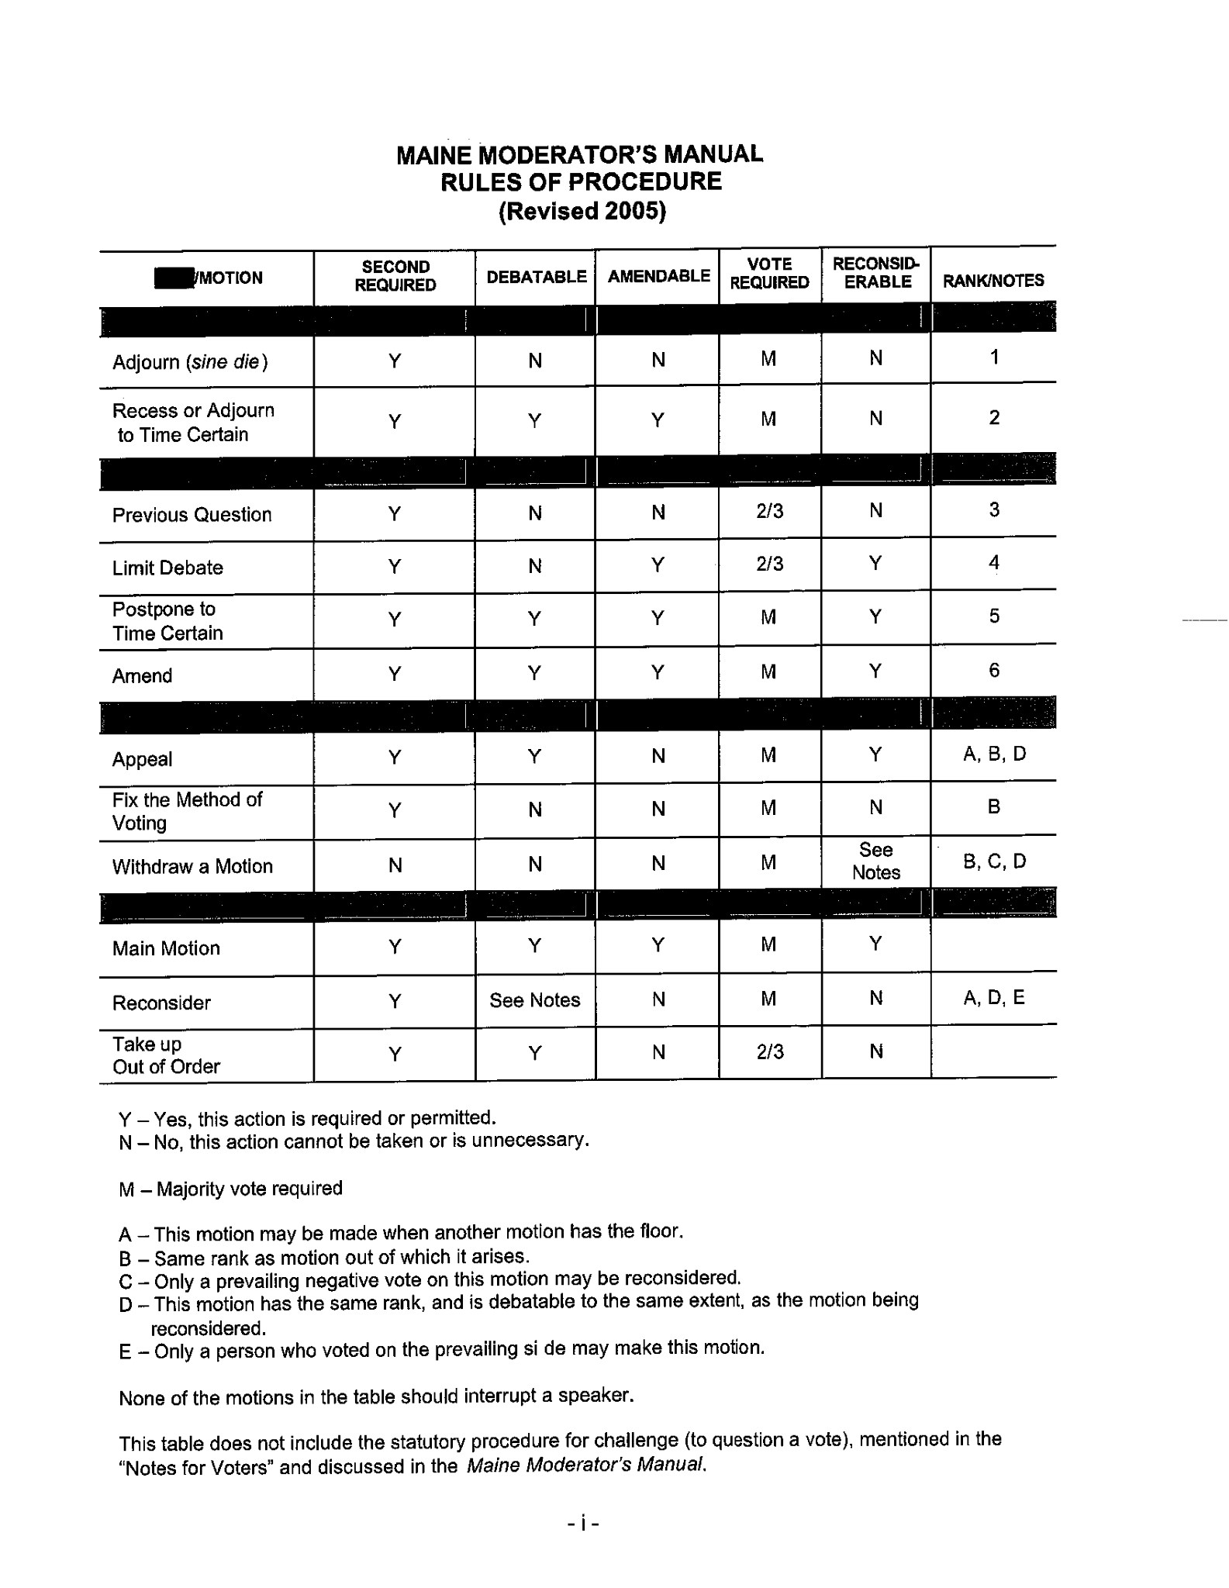
Page 2
TABLE OF CONTENTS

DIRECTORY OF MUNICIPAL OFFICERS………………………………………………………4
ADMINISTRATIVE OFFICIALS…………………………………………………………………5
GOVERNMENTAL OFFICIALS………………………………………………………………….6
REQUEST FOR COMMITTEE AND BOARD MEMBERS……………………………………..13
2018 MUNICIPAL CALENDAR………………………………………………………………….14
TOWN MANAGER REPORT…………………………………………………………………… 15
TOWN CLERK REPORT…………………………………………………………………………16

FIRE CHIEF REPORT…………………………………………………………………………….18
TOWN TREASURER'S REPORT………………………………………………………………...20
2018-19 EST. YEAR END EXPENDITURES & REVENUES…………………………………..22
DELINQUENT REAL ESTATE TAX LIST……………………………………………………...29
DELINQUENT PERSONAL PROPERTY TAX LIST…………………………………………...32
RESERVE ACCOUNT BALANCES……………………………………………………………..32
LOAN ACCOUNT BALANCES………………………………………………………………….33
FINANCIAL STATEMENTS……………………………………………………………………. 35
2019-20 PROPOSED BUDGET…………………………………………………………………..36
TOWN OF EAGLE LAKE SERVICE DIRECTORY……………………………………………52

Page 3

DIRECTORY OF MUNICIPAL OFFICERS

TOWN SELECTMEN, ASSESSORS, & OVERSEERS OF THE POOR
(Terms expire as indicated)
Michelle Raymond, Chair | 2020
Louise Fournier | 2020
Wendy Dube | 2021
Arthur Carroll | 2019
Vacant | 2022

BUDGET COMMITTEE
(Terms expire as indicated)
Reynold Raymond | 2019
John L. Martin | 2019
Michael Collins | 2019
Crystal Parent | 2019
Maurice Pelletier | 2019
Vacant

TOWN FOREST COMMITTEE
(Terms expire as indicated)
Reynold Raymond | 2019
Michael Collins | 2019
Fred Michaud | 2019
Michael Rochester | 2019
Phil Nadeau | 2019

PLANNING BOARD
(Terms expire as indicated)
John L. Martin, Chair | 2020
Paula Gardner | 2019
Gary Voisine | 2021
Tom Roy 2020 | 2020 2020
Vacant
Lauri Raymond (Alternate) | 2019

RECREATION COMMITTEE
(Terms expire as indicated)
Lisa Devoe | 2019
Sherry Plourde | 2019
Morgan Wilson | 2019

BOARD OF APPEALS
(Terms expire as indicated)
Michael Collins | 2019
Tom Pelletier | 2019
Jen Dube | 2019

HIGHWAY COMMITTEE
(Terms expire as indicated)
Michael Collins | 2019
Michael Michaud | 2019
Reynold Raymond | 2019
Darcy K. Labbe | 2019
Fred Simard | 2019

EAGLE LAKE SCHOOL BOARD DIRECTORS
(Terms expire as indicated)
Reynold Raymond | 2019
Morgan Wilson | 2020
Tom Roy | 2021

EAGLE LAKE WATER & SEWER TRUSTEES
(Terms expire as indicated)
Darcy J. Labbe, President | 2020
John L. Martin, Treasurer | 2023
Bruce Labbe | 2019
Gerald Raymond, Superintendent

Page 4

ADMINISTRATIVE OFFICIALS
John Sutherland
Town Manager, Town Clerk/Registrar, Tax Collector, Treasurer, Road Commissioner, General Assistance Administrator, Human Resources/Payroll Director, and Emergency Management Director

Angela Bossie
Deputy Town Clerk, Deputy Tax Collector, Deputy Treasurer, Accounts Payable Clerk, and Excise Tax Clerk

Rene St.Onge, Fire Chief

Andrew Dube  Code Enforcement Officer | Dennis Cyr  Local Plumbing Inspector | John Pelletier  Animal Control Officer | Dr. Paul Pelletier  Health Officer | Cyr Martin  Constable

Election Officials
Dana Nadeau | Election Warden
Anne Nadeau | Ballot Clerk
Laurie Belanger-Boutot | Ballot Clerk
Lisa Devoe | Ballot Clerk
Sue Violette | Ballot Clerk
Crystal Parent | Ballot Clerk

Page 5

GOVERNMENTAL REPRESENTATIVES

Maine Senator, Troy Jackson District 1  3 State House Station Augusta, ME 04333-0003  (207) 287-1515  Troy.Jackson@legislature.maine.gov | State Representative, John L. Martin District 151  PO Box 250  Eagle Lake, ME 04739 (207) 444-5556  John.Martin@legislature.maine.gov

U.S. Senator, Susan Collins  25 Sweden Street, Suite A Caribou, ME 04736  (207) 493-7873  http://www.collins.senate.gov/public/ | U.S. Senator, Angus King  169 Academy Street Presque Isle, ME 04769 (207) 764-5124  http://www.king.senate.gov/ | U.S. Congressman, Jared Golden 7 Hatch Drive, Suite 230 Caribou, ME 04736  (207) 492-6009  www.house.gov/golden

Page 6

Dear Friends,
It is an honor to represent Maine in the United States Senate. I am grateful for the trust the people of our state have placed in me and welcome this opportunity to share some key accomplishments from this past year.
As Chairman of the Senate Aging Committee, I worked to help ensure the well-being of our seniors. The Senior$afe Act I authored became law last year and is empowering banks, credit unions, and other financial institutions to better protect seniors from financial fraud.

Following extensive committee investigations of prescription drug pricing, additional legislation I crafted became law, ending the egregious practice of pharmacy “gag clauses” that prevented pharmacists from informing patients on how to pay the lowest possible price.

This year, I was also successful in securing an extra $425 million for Alzheimer’s research—the largest funding increase ever—bringing the total to $2.34 billion. Additionally, the bipartisan BOLD Act I authored will create public health infrastructure to combat Alzheimer’s by promoting education, early diagnosis, and improved care management.

More than 40 million Americans—including 178,000 Mainers—are caregivers for parents, spouses, children, and other loved ones with disabilities or illnesses, such as Alzheimer’s. The RAISE Family Caregivers Act I authored was signed into law last year, giving caregivers more resources and training to better balance the full-time job of caregiving. Another law I wrote will help grandparents who are raising grandchildren, largely due to the opioid addiction crisis.

In addition to helping seniors, a major accomplishment over the past year is the increased federal investment in biomedical research that is leading to progress in the fight against numerous devastating diseases. Congress has boosted funding for the National Institutes of Health by $7 billion in just the last three years, bringing total funding to more than $39 billion.

One of my highest priorities as Chairman of the Transportation Appropriations Subcommittee is to improve our nation’s crumbling infrastructure and ensure that Maine’s needs are addressed. Since the Better Utilizing Investments to Leverage Development (BUILD) Transportation Grants program, formerly known as TIGER, was established in 2009, I have secured $160 million for vital transportation projects throughout Maine.

Congress also delivered a Farm Bill last year, which includes many important provisions that will help the agriculture industry in Maine and across the country. Specifically, I secured provisions that will strengthen support for young farmers, improve local farm-to-market efforts, and increase funding for organic research.

Congress took decisive action to address the opioid addiction epidemic. In addition to appropriating $8.5 billion in federal funding last year, Congress enacted the SUPPORT for Patients and Communities Act, a comprehensive package that embraces the multipronged approach I have long advocated for this epidemic: prevention, treatment, recovery, and enforcement to stop drug trafficking.
Page 7
Maine plays a key role in ensuring a strong national defense. In 2018, Congress provided funding for five ships to be built at Bath Iron Works, which will help to keep our nation safe and provide our skilled shipbuilders a steady job. I also secured more than $162 million for infrastructure projects at Portsmouth Naval Shipyard to support their important work to overhaul Navy submarines.

A Maine value that always guides me is our unsurpassed work ethic. In December 2018, I cast my 6,834th consecutive vote, continuing my record of never missing a roll-call vote since my Senate service began in 1997.
I appreciate the opportunity to serve Maine in the United States Senate. If ever I can be of assistance to you, please contact one of my state offices or visit my website at www.collins.senate.gov. May 2019 be a good year for you, your family, your community, and our state.
Sincerely,

Susan M. Collins
United States Senator

Page 8

Dear Friends,

I hope this letter finds you well. As I am settling into my new role as your representative, I wanted to give you an update on what we are doing in D.C. and in Maine this year.

My first priority is to be accessible to you and to our communities, which is why I have opened offices throughout the Second District at the following locations:
- Caribou Office: 7 Hatch Drive, Suite 230, Caribou ME 04736. Phone: 207) 492-6009
- Lewiston Office: 179 Lisbon Street, Lewiston ME 04240. Phone: (207) 241-6767
- Bangor Office: 6 State Street, Bangor ME 04401. Phone: (207) 249-7400

My team and I are here to serve you, so please come meet my staff, voice an opinion, inform us of local events, or seek assistance with federal benefits. I come home to Maine every weekend to hear from you and see what’s happening in our communities. I appreciate you keeping us informed.

This year, I was proud to be appointed to the House Armed Services and Small Business Committees. On Armed Services, I’m using my experience serving in Iraq and Afghanistan to make sure our service members have the resources and training they need to succeed and keep us safe. Within Armed Services, I was assigned to the Seapower Subcommittee, where I am fighting for our shipyard jobs and making sure our military can count on Bath-built ships for generations to come. Beyond Bath, I will advocate for the entire network of good Maine jobs that support our troops, equipping them to carry out their duties reliably and safely.

Maine would just not be the same without our small, family-owned businesses. On the Small Business Committee, I am working to ensure our small businesses have the tools to grow, look out for their workers, and provide more good jobs to people all over Maine. Within the Small Business Committee, I was honored to be appointed Chairman of the Subcommittee on Contracting and Infrastructure. With this position, I am highlighting the need for infrastructure investment and fighting to level the playing field when small businesses compete for federal contracts.

One thing I love about Maine is that we help each other out. Whether it’s ensuring a job well done or lending a hand to a neighbor, I know you are strengthening our communities every day. I am proud to serve alongside you and look forward to all that we will accomplish together.

My wife Isobel and I wish you and your family happiness, health, and success in the year to come.

Sincerely,
Jared Golden
Member of Congress
Page 10
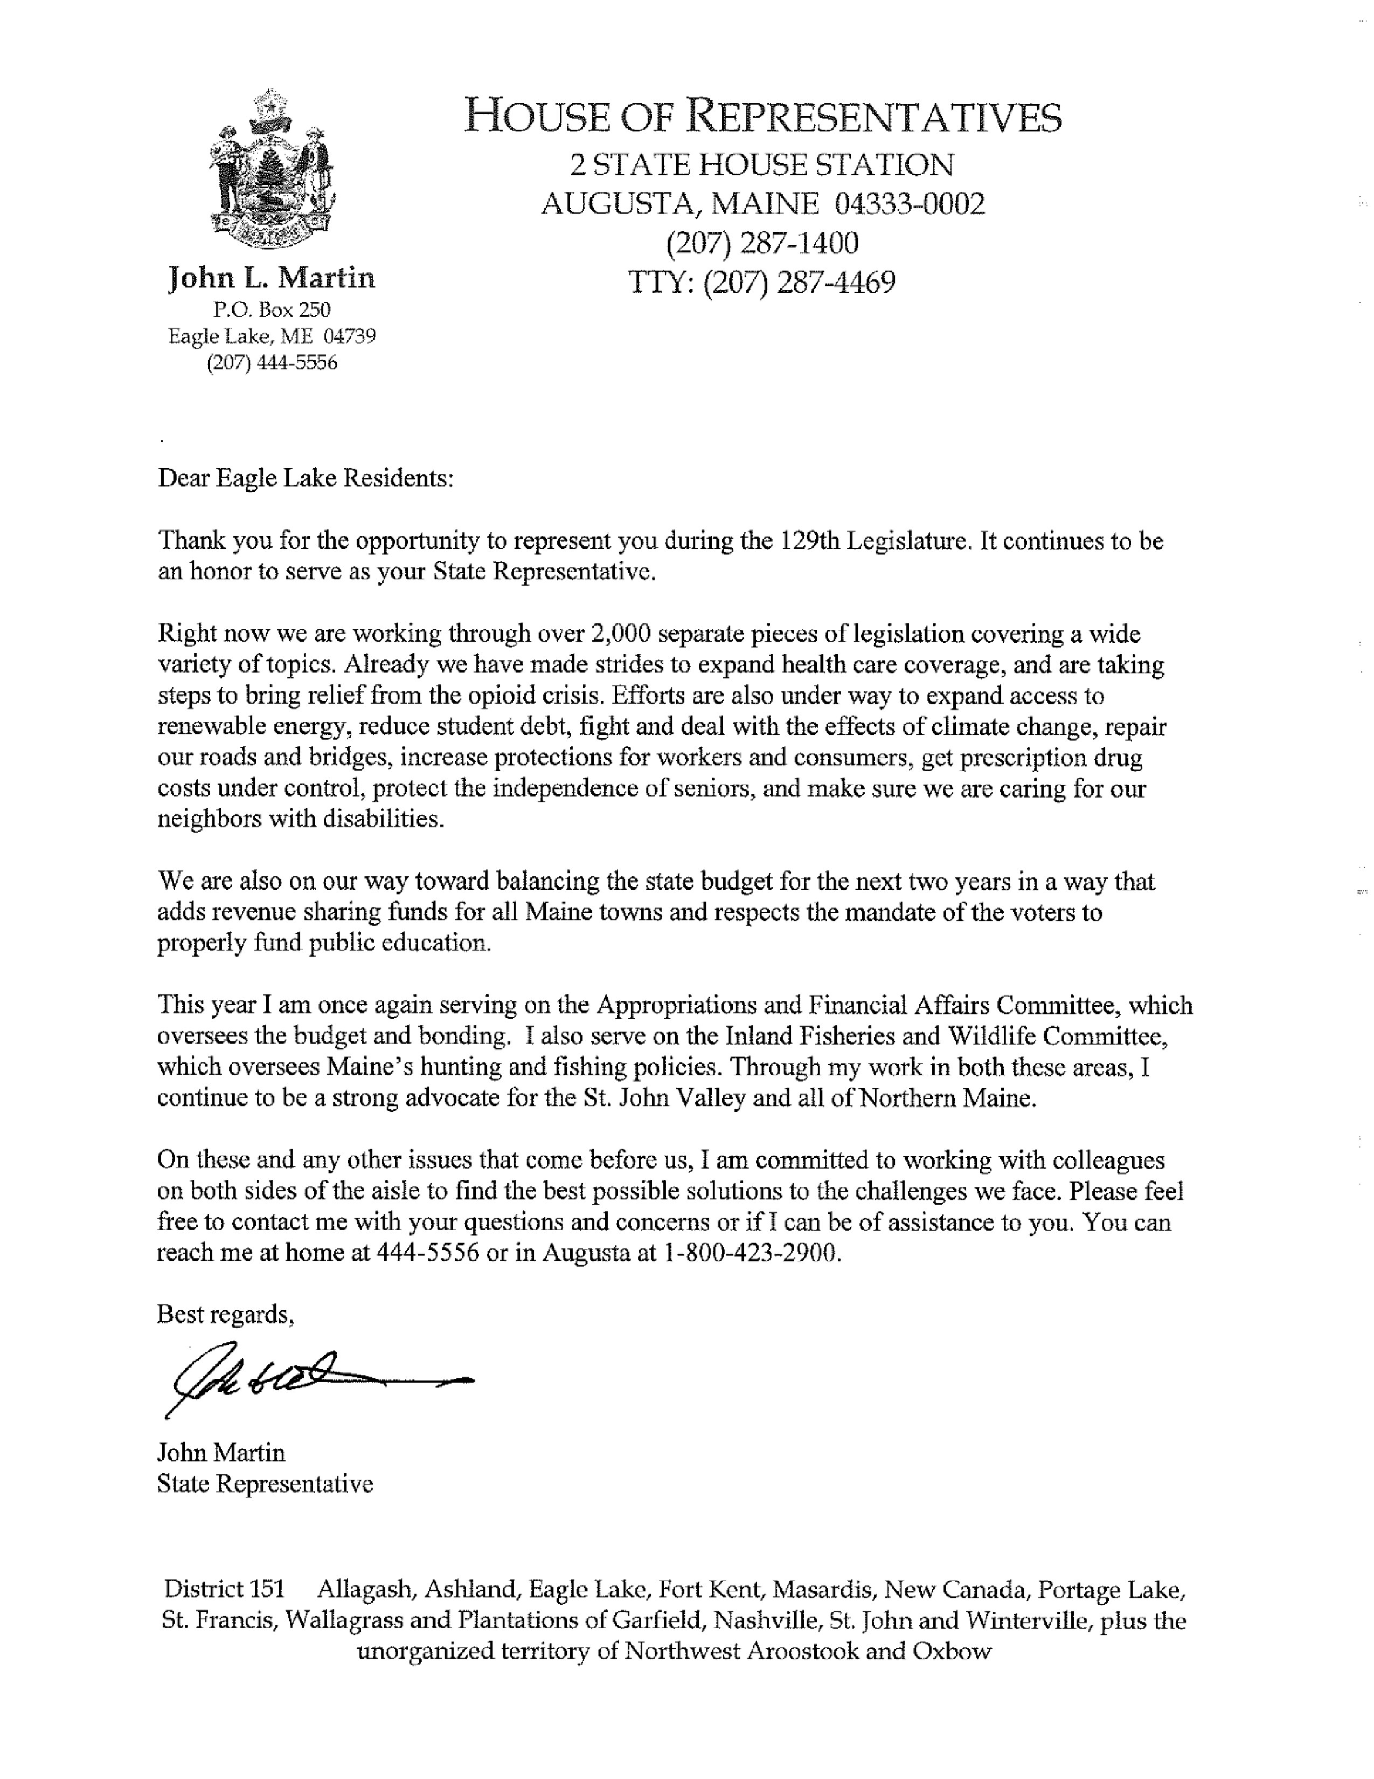
Page 11

Troy D. Jackson | THE MAINE SENATE | 3 State House Station
President of the Senate | 129th Legislature | Augusta, Maine 04333

February 22, 2019

Dear residents of Eagle Lake,

Thank you for the opportunity to serve again as your State Senator. I am honored and humbled by the responsibility of representing you, your families, and our area in Augusta. I promise to work hard to do just that.

I’m honored and deeply humbled to have been elected by my colleagues as President of the Maine Senate for the upcoming legislative session. In this new role, I am committed to being an advocate for the people of Aroostook County. I know that folks in our part of the state often feel like no one down in Augusta is listening to our needs. It is my goal to change that.

At the top of my priority list is supporting manufacturing, agriculture, fishing and other industries that make high-quality products and produce jobs here in our state. I will also work to lower health care costs, take on “Big Pharma” to make prescription drugs more affordable, and work to enact a strong “Buy Maine, Buy American” law that will bolster our economy and support jobs.

If you have other concerns or ideas for legislation, my door is open. Please feel free to call or email me anytime. I can be reached on my cell at (207) 436-0763 or at the State House at (207) 287-1500. Please feel free to email me anytime at Troy.Jackson@legislature.maine.gov. I also encourage you to sign up for my email newsletter, where I provide regular legislative updates. You can do so at www.mainesenate.org.

Sincerely,
Troy Jackson
Senate District 1

State House (207) 287-1500 * TTY (207) 287-1583 * Fax (207) 287-5862 * Toll Free 1-800-423-6900
Email:Troy.Jackson@legislature.maine.gov * Web Site: legislature.maine.gov/senate

Page 12

REQUEST FOR COMMITTEE AND BOARD MEMBERS
It is often very difficult to find people with the time, expertise, and the willingness to serve on committees and boards which are part of the administrative process of this community. It is important for a community to have diversity in their committees and boards in order to ensure that all levels of ideas and concerns are heard; and that those ideas and concerns are considered when decisions are made that affect the residents of Eagle Lake.
If you have the willingness to serve on any of the boards or committees listed below, please place a check mark next to the board or committee of your choice and return this page to the Town Office.
We thank you for your interest to be engaged and involved in your community.


To the Board of Selectmen:
I would be interested and would like to serve on the following committee(s) or board(s). [ ] Planning Board
[ ] Town Forest Committee
[ ] Recreation Committee
[ ] Board of Appeals
[ ] Economic Development [ ] Highway Committee
[ ] Comprehensive Planning Committee [ ] Budget Committee

Full Name Date

Address

Telephone Number

Page 13

2019 MUNICIPAL CALENDAR
Board of Selectmen Meetings are scheduled for the third Wednesday of each month at 5:30 P.M.

January 1 |  | Dog licenses are due on all dogs’ 6-months or older. Owners must bring neutering/spaying certificate and rabies certificate.
February 1 |  | A $25.00 late fee is charged on all unlicensed dogs
February 28 |  | 2 or more axle trailer registrations expire
April 1 |  | Real estate assessments are made. Personal property assessments are due to Assessors. Property Tax Exemption applications  (Veterans, Homestead) are due
June 3 |  | 2018 Property liens are applied
June 11 |  | Municipal Election
June 12 |  | Annual Town Meeting
June 30 |  | ATV and Snowmobile registrations expire
July 1 |  | 2019 Property taxes are due
October 1 |  | Interest begins on 2019 taxes (if approved)
November 25 |  | Foreclosure begins on 2017 unpaid taxes
November 5 |  | Election Day
December 31 |  | Boat registrations expire

2019 Town Office Holiday Schedule

Monday, January 21st | Martin Luther King, Jr. Day
Monday, February 18th | President’s Day
Monday, April 15th | Patriot’s Day
Monday, May 27th | Memorial Day
Thursday, July 4th | Independence Day
Monday, September 2nd | Labor Day
Monday, October 14th | Columbus Day
Monday, November 11th | Veteran’s Day
Thursday, November 28th & Friday, November 29th | Thanksgiving Holiday
Wednesday, December 25th | Christmas Day
Wednesday, January 1, 2020 | New Year’s Day

Page 14

TOWN MANAGER REPORT

This past year has seen a number of changes and new faces at the Eagle Lake Town Office. The departure of Leona Sifton and Sandra Fournier left big shoes to fill. Angela Bossie and Abriana DeLena have been doing a good job filling those shoes and learning as we move forward. My first day began September 10, 2019 and my wife and I have enjoyed making Eagle Lake our home.
Since I have been in Eagle Lake we have had a number of projects going on to move the community forward. A paving project on Old Main Street saw the old pavement ground up and the millings were relocated to Devoe Brook Road as we extended from the surface area on. We added a new roof, siding, windows and an interior upgrade to the Skating Rink Building. The building looks sharp and will serve the community well for years to come. We also installed lighted Christmas Wreaths on Main Street to make our community more festive for the holiday season. I heard many positive comments about the new holiday decorations. I am working with the Forest Committee to update the Town Forest Harvest Plan which I am hoping to have completed by late summer. We upgraded the Town website to a model that will allow us to display the natural beauty of our community while providing all the information that was on the previous site. We are continuing to pursue LED street lighting for our community to benefit from the cost savings in lighting our streets. We are also working with Eagle Lake Fire Chief Rene St. Onge on upgrading his communications with his firefighters as they respond to emergencies in our community.
One of the biggest issues the community faces is the future of the former school and library property. At a public hearing in September, residents voiced their concerns of continuing to own the property citing heating and ongoing maintenance as key concerns. We had a referendum in April where residents voted overwhelmingly to auction the school and library while keeping a right of way to the playground, keeping the tennis courts and athletic fields. We are currently working with a surveyor to come up with a work plan that separates the items the community wishes to keep and identifies the parcel to be auctioned off.
Pond Brook Estates is remaining full or close to full occupancy. This has allowed us to increase the amount allocated to the budget by $ 17,500 to $ 42,500. This is equal to one-half the annual bond payment.
At this time I would like to thank the talented dedicated staff in Eagle Lake. Maintenance man Chris Cote does everything from repairs at Pond Brook Estates to road maintenance. Deputy Clerk Angela Bossie keeps our office running smoothly with the help of Abriana DeLena.
I want to thank Eagle Lake Fire Chief Rene St. Onge for his efforts as Eagle Lake’s Fire Chief. I also want to thank the volunteers for their service and being there for our community when we need them.
I want to thank the Skating Rink Staff for keeping the rink open this winter, Dana Nadeau for his service as Election Warden and I also want to thank the Ballot Clerks for their efforts. These people help our elections run smoothly.
Andrew Dube- Code Enforcement Officer, John Pelletier-Animal Control Officer, Dr. Paul Pelletier-Health Officer, Dennis Cyr- Licensed Plumbing Inspector and Cyr Martin-as Constable are all appreciated for their efforts.
I want to thank the numerous committee members that I worked with. You are a valuable part of our community and your efforts are appreciated.
I also want to thank the Board of Selectmen for their guidance and support. It has been a pleasure to serve this community as part of this team.

John Sutherland
Eagle Lake Town Manager
Page 15

TOWN CLERK REPORT
Maine Law required that all vehicles 1995 and newer must have a title. When registering a vehicle for the first time, here is a brief list of common items that are required in order for the Town to process your registration:
- Current insurance card
- Old registration if transferring any excise tax credit
- Current mileage
- Bill of sale and seller’s title signed over to you (if private sale)
- Proof of sales tax paid and title application (if dealer sale)
For a renewal, bring your old registration, current insurance card and mileage.

When registering a recreational vehicle such as a boat, ATV, or snowmobile for the first time:
If Dealer Sale, bring the following items:
  - Proof of sales tax paid
  - Temporary registration
  - Length and motor size (if you are registering a boat) If Private Sale, bring the following items:
  - Bill of sale indicating the serial number and the seller’s name and address
  - Length and motor size (if you are registering a boat)
  - If trailer and boat purchased together - must separate cost of each on bill of sale
For a renewal, bring your old registration.

ALL FIRST TIME HUNTERS, archery included, that are 16 years of age and older, are required to complete a hunter safety course prior to being able to purchase a hunting or archery license.

MAINE RESIDENT LIFETIME LICENSE APPLICATIONS are available to
applicants 5 years of age and younger than 65 years of age. Applications are available at the Eagle Lake Town Office.

Hunting & Fishing License Fees
 | Resident | Non-Resident
Combination Hunting & Fishing | $45.00 | $152.00
Hunting (16 yrs +) | $28.00 | $117.00
Fishing (16 yrs +) | $27.00 | $66.00
Junior Hunting (10-15 yrs) | $10.00 | $37.00
Archery (16 yrs +) | $27.00 | $76.00
Muzzle loading | $14.00 | $70.00
Military Combination | $5.00 | N/A
Military Dependent Combination | $22.00 | N/A
Military Dependent Hunting | $12.00 | N/A
Military Dependent Fishing | $12.00 | N/A
Super pack | $203.00 | N/A
Small Game Hunting | $17.00 | $77.00
Bear Hunting | $29.00 | $76.00
Page 16

The fees for licensing neutered/spayed dogs are $6.00 and require a neutering/spaying certificate. Dogs that are not neutered/spayed or failed to provide a certificate are $11.00. A rabies certificate (not the tag) is also required at the time of licensing. If a dog is not registered by January 31st, a $25.00 late fee per dog will be assessed.

Marriage licenses are $40.00

Certified copies of birth, death, and marriage certificates are $15.00 for
the first copy and $6.00 for each additional copy of the same record

Clerk Issued and Filed Registrations, Licenses, & Certificates
Inland Fisheries & Wildlife
Boats | 308
ATVs | 196
Snowmobiles | 216

Motor Vehicle Registrations
Passenger Cars | 506
Commercial Cars | 66
Motorcycles/Mopeds | 24
Trailers | 137

Dog Licenses
Neutered/Spayed | 81
Non Neutered/Spayed | 17
Kennels | 8
Service Animals | 0

Vital Records
Certified Birth | 49
Additional Copies of Birth | 12
Certified Death | 15
Additional Copies of Death | 31
Certified Marriage | 7
Additional Copies of Marriage | 0
Marriage Licenses Issued | 6
Disposition Permit | 15

Page 17

FIRE CHIEF REPORT

Eagle Lake Fire Department was busy this past year putting out fires, supplying mutual aid, performing rescue calls, providing regulated trainings, and holding our annual fundraisers. Trainings are provided twice a month and monthly equipment checks ensure the equipment is in proper working order. These activities help keep our skills sharp to provide efficient and effective fire protection and rescue services to the communities we serve.

Our Steak and Lobster Feed will be held on June 29th. You can purchase tickets for $25.00 each at the local stores in Eagle Lake or from any member of the Fire Department. We hope to see you all there! We had an amazing show for Our Haunted Forest this year and we plan on doing this event again this year. We hope to see you all there.

We have been working with the Town Manager for grants that will enable us to purchase a new pumper truck if we are successful in our efforts. Our current fleet of trucks is getting old and worn-out. We need to address this issue before it affects our Department’s ability to serve the residents of our community.

In closing, I would like to thank the Board of Selectmen, Town Manager and the office staff for their assistance throughout the year. I would also like to thank our newest volunteer firefighters for joining our Department, becoming involved and putting their community’s needs first. All of the officers and members of Eagle Lake Fire Department are key to our continued success as a Department. Thank you for your dedication and investment in our community.

Respectfully,

Rene St.Onge 501
Fire Chief, Town of Eagle Lake

Page 18
EAGLE LAKE FIRE DEPARTMENT

Volunteer Firefighter Administration
Rene St.Onge  Jeff Roy | Chief  Assistant Chief
Robert St. Germaine | Captain
Brandon L’Italien | 1st Lieutenant
Troy Nadeau | 2nd Lieutenant
Dave Watson  Corey Bourgoin | Safety Officers
Brian Bouchard | Firefighter
Glen Kleinert | Firefighter
Lee Devoe | Firefighter
Julian Goodman  Alex Raymond | Firefighter  Firefighter
Lisa Devoe | Dispatcher
Serge St. Onge | Dispatcher

Fire Safety Tips from the National Fire Protection Association (NFPA):
- Watch you’re cooking: Stay in the kitchen when you are cooking. If you must leave, even for a short time, turn off the stove.
- Give space heaters space: Keep fixed and portable space heaters at least three feet from anything that can burn. Turn off heaters when you leave the room or go to sleep.
- Smoke outside: Ask smokers to smoke outside. Have sturdy, deep ashtrays for smokers.
- Keep matches and lighters out of reach of children: Keep matches and lighters up high, preferably in a cabinet with a child lock.
- Inspect electrical cords: Replace cords that are cracked, damaged, have broken plugs or loose connections.
- Be careful when using candles: Keep candles at least one foot from anything that can burn. Blow out candles when you leave the room or go to sleep.
- Have a home fire escape plan: Make a home fire escape plan and practice it at least twice a year.
- Install smoke alarms: Install smoke alarms on every level of your home, inside bedrooms and outside sleeping areas. Interconnect the alarms throughout the home. When one sounds, they all sound.
- Test smoke alarms: Test smoke alarms at least once a month and replace conventional batteries once a year. Replace any smoke alarm that is more than 10 years old.
- Install sprinklers. If you are building or remodeling your home, install residential fire sprinklers. Sprinklers can contain and may even extinguish a fire in less time than it would take for the fire department to arrive.

Page 19

TOWN TREASURER’S REPORT

The 2018 tax mil rate was set in July 2018 at 17.20 and we collected an estimated 94% by year end, June 1, 2019. Properties are taxed according to worth. This value is determined by the contracted Assessing Agent, Shirley Bartlett.

Your value assessment is multiplied by the local tax rate or millage rate. Another common name is the municipalities “mil rate”. Mil rates are expressed as tenths of a penny, a tenth of a penny is also equal to 1/1000 of a dollar. For example, 17.20 mils would translate to17.20 tenths of a penny; a property assessed at $125,000, the property tax would be equal to:

17.20 mils = 17.20 x 1/1000 =0.01720
0.01720 x $125,000 = $2,150.00 in tax

Tax bill payments can be sent periodically for whatever amount you are comfortable sending. Please identify what account you would like your payment applied to. As always, if there is interest accrued on your account, your payment will be applied to the interest first then the principal balance.

Avoid potential lien charges and interest fees by prepaying
If you have questions about your tax bill or scheduling payments, please contact the Town Office at (207) 444-5511.

2019 Tax Collection Schedule

30-Day Notice on Uncollected 2018 Taxes | April 26, 2019
Tax Liens placed on Uncollected 2018 Taxes | June 3, 2019
Interest on 2019 Taxes Begins (if approved) | October 1, 2019
30 – 45 Day Foreclosure Notice on 2017 Taxes | October 16, 2019
Foreclosure on Uncollected 2017 Taxes | November 25, 2019

Page 20
What Did Your 2018-2019 Taxes Pay For?

41% of Eagle Lake’s taxes are attributed to Municipal Operations. This covered the costs of road and town facilities expenses, street lighting, municipal operations and the fire department. This also covers debt service on town loans.

45% of Eagle Lake’s taxes are attributed to education for Eagle Lake’s students.

7% of Eagle Lake’s taxes are attributed to the County. This covers the Eagle Lake’s share of the costs for County government operations. This includes the Courts, Registry of Deeds, Sheriff’s Department, Emergency Management and County Administration.

5% of Eagle Lake’s taxes are attributed to NASWA for handling the community’s municipal solid waste.

2% of Eagle Lake’s taxes are attributed to Ambulance Service Inc. to provide ambulance service to our community.
2018-19 Mil Rate Distribution

 | 2018 | 2017 | Change | Percentage
 | 17.20 | 17.20 | .00 | 0%
County Tax | $114,245 | $ 101,318 | +$12,927 | +11.30%
NASWA | $ 87,767 | $ 76,028 | +$11,739 | +13.4%
ASI | $ 25,725 | $25,284 | +$441 | +1.8%
Municipal | $740,744 | $703,568 | +$37,176 | +5.02%
MSAD 27 | $818,830 | $853,919 | -$35,089 | (-4.10%)
State Revenue Sharing | $40,000 | $38,000 | $ 2,000 | +5.25%
Page 21

2018 - 2019 EST. YEAR END EXPENDITURES & REVENUES

 | 2018 - 2019  Budget | Est. EOY  Balance
01 - Salaries
05 - Town Manager | 51,780.00 | 48,021.00
10 – Clerk-Part Time | 11,585.00 | 11,724.00
15 – Clerk-Full Time | 28,132.00 | 28,164.00
21 – Maintenance PT | 21,915.00 | 21,756.00
22 – Maintenance PT SNL | 4,862.00 | 4,598.00
25 - Town Officer | 3,750.00 | 3,750.00
 | 122,024.00 | 118,013.00
02 - Mileage
05 - Mileage | 0.00 | 0.00
 | 0.00 | 0.00
03 - Benefits
05 - SS/MC | 11,200.00 | 9,849.00
10 - Unemployment | 1,950.00 | 1.950.00
15 – Workers Comp | 3,325.00 | 3,680.00
20 - Health Insurance | 27,100.00 | 20,703.00
 | 43,575.00 | 36,182.00
04 - Auditor
05 - Auditor | 6,550.00 | 6,500.00
 | 6,550.00 | 6,500.00
05 - Planning/Dev
05 - Salaries | 2,000.00 | 2,000.00
25 - Advertising | 500.00 | 500.00
 | 2,500.00 | 2,500.00
10 – CEO/ACO
05 - CEO Salary | 4,260.00 | 4,260.00
12 - LPI Salary | 800.00 | 800.00
20 - ACO Salary | 450.00 | 450.00
35 - ACO Mileage | 300.00 | 300.00
 | 5,810.00 | 5,810.00

Page 22
Expenses
 | 2018 - 2019  Budget | Est. EOY  Balance
15 - Hydrants
00- Hydrant Rental 05 - Hydrant Rental | 77,565.00 | 77,564.00
 | 77,565.00 | 77,564.00
20 - Street Lights
05 - Street Lights | 16,375.00 | 17,655.83
 | 16,375.00 | 17,655.83
25 - Incidentals
05 - Advertising | 1,300.00 | 2,736.00
10 - Assessor Exp. | 3,500.00 | 1,800.00
15 - Computer Exp. | 1,500.00 | 2,695.00
20 - MMA Dues | 1,886.00 | 1,886.00
25 - Election Exp. | 2,100.00 | 2,163.00
30 - Electricity | 2,000.00 | 2,080.00
35 - Employee Exp. | 1,000.00 | 456.00
40 - Heating | 2,300.00 | 2,662.00
45 - Legal Exp. | 1,000.00 | 1,105.00
50 - Misc. | 500.00 | 6,890.00
55 - Copier | 1,500.00 | 1,860.00
60 - Postage | 1,250.00 | 1,250.00
65 - Sewer | 275.00 | 319.00
75 - Bldg. Exp. | 2,000.00 | 1,783.47
80 - Office Exp. | 3,300.00 | 1,823.00
85 - Telephone | 1,500.00 | 1,487.92
86 - Cell Phone | 600.00 | 500.00
90 - Water | 1,200.00 | 1,484.00
91 - Internet | 900.00 | 894.00
92 - Lien Cost | 1,600.00 | 1,200.00
93 - NMDC Dues | 2,100.00 | 2,113.00
94 - Tax Maps | 800.00 | 0.00
96 - Trio Subs | 11,550.00 | 11,535.00
97 – Emp. Training | 500.00 | 590.00
98 – Emp. Travel | 500.00 | 590.00
 | 46,661.00 | 51,902.39
30 - Town Forest
05 - Equip. Exp. | 0.00 | 0.00
20 - Supplies | 0.00 | 0.00
25 - Trees | 0.00 | 0.00
 | 0.00 | 0.00

Page 23
Expenses
 | 2017 - 2018  Budget | Est. EOY  Balance
40 - Insurance
05 - Bonds/TO | 18,070.00 | 19,526.00
10 - Buildings | 0.00 | 0.00
15 - Vehicle | 0.00 | 0.00
25 - Town Forest | 0.00 | 0.00
50 - Liability | 0.00 | 0.00
 | 18,070.00 | 19,526.00
43 - Bonds & Note
10 - Pond Bk | 85,000.00 | 84,884.00
15 - Katahdin | 23,460.00 | 23,458.00
25 – Road Repair | 63,150.00 | 63,134.00
 | 171,610.00 | 171,476.00
45 - Fire Dept.
05 - Bldg. Imp. | 400.00 | 400.00
10 - FD Dues | 100.00 | 100.00
15 - Electricity | 1,800.00 | 1,877.01
20 - Gas & Oil | 500.00 | 452.66
25 - Heat Oil | 2,500.00 | 2,406.00
30 - Misc. | 500.00 | 336.00
35 - Equip Purchase | 750.00 | 0.00
40 - Parts/Repair | 5,000.00 | 3,665.00
45 - Payroll FM | 4,000.00 | 3,326.00
50 – Payroll Officers | 8,000.00 | 8,266.00
55 - Sewer | 300.00 | 174.00
65 - Bld. Sup | 500.00 | 0.00
70 - Office Sup | 150.00 | 0.00
75 - Telephone | 1,000.00 | 1,063.00
80 - Training | 500.00 | 80.00
83 - Medical | 1,80.00 | 674.00
85 - Water | 1,195.00 | 1,310.00
91 - 911 calls | 1,510.00 | 1,511.00
 | 30,180.00 | 25,640.67
46 - Fire Reserve  05 - Fire Reserve | 5,000.00 | 5,000.00
 | 5,000.00 | 5,000.00

Page 24
 | 2018- 2019  Budget | Est. EOY  Balance
50 - Road Maintenance
05 - Winter Sand | 8,000.00 | 8,000.00
10 – Salt | 5,000.00 | 4,686.00
15 - Snow/Sly Brook | 24,500.00 | 24,500.00
20 - Snow/Town | 26,750.00 | 26,750.00
25 - Equip Hire | 40,500.00 | 7,332.00
 | 104,750.00 | 71,268.00
52 - Highway Reserve  05 - Highway Reserve | 5,000.00 | 5,000.00
 | 5,000.00 | 5,000.00
53 – Mun. Snow Rem  05 - Snow Removal | 16,975.00 | 16,975.00
 | 16,975.00 | 16,975.00
60 - General Assistance
05 - Case 1 | 500.00 | 500.00
10 - Case 2 | 500.00 | 500.00
15 - Case 3 | 500.00 | 500.00
 | 1,500.00 | 1,500.00
63 – Library Building
05 - Electrical | 0.00 | 27.00
10 – Heating Oil | 0.00 | 0.00
15 – Sewer/Water | 410.00 | 1,213.00
20 – Building Repair | 0.00 | 0.00
25 – Snow Removal | 0.00 | 0.00
 | 410.00 | 1,240.00
65 – Elementary School Building
05 - Electrical | 2,700.00 | 2,042.00
10 – Heating Oil | 12,500.00 | 16,714.00
15 – Sewer/Water | 1,315.00 | 4,322.00
20 – Building Repair | 0.00 | 731.00
25 – Snow Removal | 3,000.00 | 3,000.00
 | 19,515.00 | 26,809.00
75 - Equipment
05 - Repairs | 1,000.00 | 944.00
10 - Fuel | 1,000.00 | 1,171.42
15 - Small Equip | 350.00 | 717.00
20 - Maintenance | 2,500.00 | 376.00
 | 4,850.00 | 3,208.42

Page 25
Expenses
 | 2018 - 2019  Budget | Est. EOY  Balance
80 - Rec Bldg.
05 - Electricity | 1,000.00 | 705.00
10 - Heating Oil | 500.00 | 717.98
20 – Misc. | 500.00 | 70.00
30 – Bldg. Repair | 200.00 | 100.00
35 - Sewer | 550.00 | 620.00
50 - Telephone | 425.00 | 423.00
55 - Water | 2,400.00 | 2,440.00
 | 5,575.00 | 5,075.98
81 - Winter Trail
05 - Ski-Trails | 2,500.00 | 2,500.00
10 - Snow-Mobile | 2,000.00 | 2,000.00
 | 4,500.00 | 4,500.00
82 - Rec. Program
05 - Labor | 7,500.00 | 6,410.00
10 - Program Act. | 2,000.00 | 2,515.32
 | 9,500.00 | 8,925.32
83 - Swim Program
05 - Pool | 3,440.00 | 0.00
 | 3,440.00 | 0.00
85 - Bt. Landing
10 - Grounds Main | 500.00 | 500.00
20 - Electricity | 600.00 | 579.00
25 - Mat/Sup | 400.00 | 67.00
 | 1,500.00 | 1,146.00
90 - Beach/Park
05 - Christ Tree | 6,875.00 | 6,954.00
10 - Electricity | 1,430.00 | 1,284.00
16 – Water and Sewer | 570.00 | 790.56
20 – Ground Improvement | 0.00 | 270.00
25 - Maintenance | 930.00 | 618.00
 | 9.805.00 | 9,916.56

Page 26
Expenses
 | 2018 - 2019  Budget | Est. EOY  Balance
95 - Tennis/BB
05 - Electricity | 400.00 | 346.00
15 - Grounds | 500.00 | 0.00
20 - Supplies | 100.00 | 0.00
 | 1,000.00 | 346.00
96 - Unclassified
05 - AAAA | 750.00 | 750.00
10 - ACAP | 175.00 | 173.00
15 - Legion | 1,500.00 | 1,500.00
20 - Animal Shelter | 100.00 | 100.00
25 - Homeless Shelter | 864.00 | 864.00
30 - Homemaker | 500.00 | 0.00
45 - Red Cross | 375.00 | 375.00
50 - SJVSWC | 315.00 | 315.00
60 - Senior Citizen | 600.00 | 600.00
81- FK Chamber of Commerce | 150.00 | 150.00
82- Long Lake Ice Fishing Derby | 500.00 | 500.00
87 - EL Irving 100 | 500.00 | 500.00
88 - PAWS | 175.00 | 175.00
 | 6,504.00 | 6,502.00
Totals | 740,744.00 | 700,182.17
Profit (Loss) for Undesignated Fund Bal. |  | 40,561.83

Page 27

REVENUE
2018 - 2019 Est. EOY
Budget Balance

100 - Motor Vehicle Excise | 160,000.00 | 174,000.00
101 - Motor Vehicle Agent Fee | 3,000.00 | 2,650.00
102 - Inland Fisheries Bt. Excise | 4,500.00 | 3,702.00
103 - Inland Fisheries Agent Fee | 1,000.00 | 915.00
104 - Dog License Agent Fee | 100.00 | 114.00
105 - Building Permit Fees | 2,000.00 | 1,650.00
106 - Plumbing Permit Fee | 0.00 | 32.26
107 - Clerk Fees | 1,500.00 | 1,100.00
108 - Lien Cost | 2,500.00 | 2,547.93
110 - Miscellaneous Rev | 1,500.00 | 800.00
114 - Revenue Sharing | 40,000.00 | 40,000.00
115 - Tree Growth | 17,500.00 | 17,729.52
116 - Highway Block Grant | 13,500.00 | 13,400.00
117 - General Assistance | 200.00 | 200.00
118 - Boat Landing | 3,240.00 | 3,420.00
120 - Veterans Reimbursement | 1,200.00 | 1,150.00
121 - Interest on Taxes | 9,500.00 | 8,768.44
122 - Interest on deposits | 1,500.00 | 0.00
123 - Homestead Reimbursement | 0.00 | 41,221.00
125 - Recreation Assessment | 6,097.00 | 3,722.88
126 - Fire Dept. Assessment | 27,030.00 | 27,348.51
127 - Pond Brook Estates | 25,000.00 | 25,000.00
132 - Snowmobile Reg. Refund | 700.00 | 820.88
135 - Faxes & Photocopies | 100.00 | 79.50
138- NASWA Revenue | 2,500.00 | 2,500.00
139 - BETE Reimbursement | 0.00 | 21,079.00
140 - North Woods Gate Fee | 150.00 | 82.00
141 - Industrial Park | 4,400.00 | 0.00
144-Highway Reserve | 13,500.00 | 13,500.00
Undesignated Surplus | 50,000.00 | 50,000.00
Revenue Totals | 392,217.00 | 457,532.92
Profit (Loss) for Undesignated Fund Balance |  | 65,315.92

Page 28

DELINQUENT REAL ESTATE TAX LIST
As of April 30, 2019

NAME | 2018 | 2017
AROOSTOOK TIMBERLANDS | 3,161.65
AROOSTOOK TIMBERLANDS | 319.63
AROOSTOOK TIMBERLANDS | 1,450.67
AROOSTOOK TIMBERLANDS | 13,240.22
AROOSTOOK TIMBERLANDS | 20.66
BALD EAGLE, INC | 1,639.78 | 1,802.88
** BOUTOT, ALLAN D. & LAURIE A | 721.26 | 761.01
BLANCHETTE, ROSE M. | 1,144.50
BLANCHETTE, ROSE M. | 204.36
** BODLUC, JOSEPH | 249.39
BROWN, JOHN M. | 951.72
** CLAVETTE, ALPHIE J. II | 1,122.89
** DEVOE, GLENNWOOD, & MARY | 2,582.68
** DIONNE, RONDA L. | 490. 73
DROLET, JEFFERY | 434.89 | 502.16
** DUBE, DANIEL ROBERT | 1,459.68
DUBE, RINA | 1,268.77 | 854.76
DUNNELLS, SR., DANIEL L. | 78.28 | 123.39
DUNNELLS, SR., DANIEL L. | 977.00 | 1,077.97
DUNNELLS, SR., DANIEL L. | 814.91 | 905.80
EAGLESON, PATSY N. | 132.32
** GAGNON, SHAWN C. & BETHANY | 2,481.41
** GAGNON, SHAWN C. & BETHANY | 1,400.25
GOODMAN, JULIAN | 6,742.10
GOODMAN, JULIAN, GOODMAN, ERICA | 1,104.88
GOODMAN, JULIAN, GOODMAN, ERICA | 198.96
GOODMAN, JULIAN, GOODMAN, ERICA | 476.32
GOODMAN, JULIAN, GOODMAN, ERICA | 191.75
GOODMAN, JULIAN, GOODMAN, ERICA | 557.36
GOODMAN, JULIAN, GOODMAN, ERICA | 36.87
GRAINGER, THOMAS F. | 526.75
*GRAY, CHARLENE ELIZABETH | 433.24
** HICKS, MICHAEL & CATHRYN | 1,335.41
JANDREAU, SHON & CRYSTAL | 1,310.19
KALAYDZHAN, LUDMILA | 548.36 | 87.37
KETCHEN, BRANDON M | 589.78
KRAJEWSKI, DIANNE & PELLETIER, GEORGIANNE | 2,767.23 | 2,979.47
** LANDRY, KEVIN E. | 1,785.67 | 1,739.63
* LATVIS, LOUISE | 2,159.60
LONG, LARRY | 411.02
** LOZIER, BERTHA | 625.80
LUGDON’S LODGE LLC | 989.61 | 1,102.83
LUGDON’S LODGE LLC | 3,848.53
MAD ROCK, INC | 1,027.43 | 1,131.53
MARTIN, ANNIE LYNN | 1,331.81
MARTIN, BARBARA | 1,265.17 | 1,376.28
MARTIN, JOHN L. | 422.29 | 488.77
MARTIN, JOHN L. | 105.30 | 152.09
MARTIN, JOHN L. | 1,227.35 | 1,343.87
MARTIN, JOHN L. | 1,382.24 | 1,508.38
MARTIN, JOSEPH | 1,086.74
MARZANO, DAVID CHARLES | 202.56
** MARZANO, EDWINA S. | 1,356.18
MAZZARELLA, TONY | 454.39
MUNSON, CHELSEA & POLAKOWSKI, STEVE | 1,816.28
NADEAU, COLLEN HEIRS & C/O COLLEEN NADEAU | 117.74
** NADEAU, TROY | 35.06
PARKS, ANDREW | 876.15 | 322.63
PELLETIER, RELLA | 921.17 | 1,033.97
PHILIP BLANCHETTE CULTURAL CENTER | 845.53 | 938.32
PLOURDE, VAUGHN & LINDA | 1,702.82
PLOURDE, RODERICK & SHERRY A. | 1,495.70
RAYMOND, JENNIFER | 126.92
RAYMOND, JENNIFER | 1,380.43
** RCC-2 | 4,029.75
RICCIARDI, BENJAMIN | 2,021.60
RICCIARDI, BENJAMIN & BETTY | 2,052.22
ROBERTSON, KYLE & BABIN, OLIVIA | 3,013.57
** ROCHESTER, MICHAEL & NAOMIE | 423.24
** ROOSEVELT CONFERENCE CENTER | 4,550.25
ROY, TOM J. | 1,121.09
* SAUCIER, BOBBY & LISA | 1,673.35
** SAUCIER CURTIS M & CHRISTINE M | 1,776.66
SAUCIER, RODERICK H | 645.61
SAUCIER, RODERICK H & VICKIE M | 1,263.37 | 1,384.05
SOUCIE FAMILY FIREWOOD, INC | 1,708.22 | 2,712.59
SURRELLS, DANIEL L. | 1,468.69
* TARDIFF, DANIEL J & MONICA J | 355.82
TARDIFF, SHAWN | 352.05 | 414.17
THERIAULT, BRIAN J. | 312.42
** THERIAULT, NATHAN | 2,887.90
THERIAULT, STEVE & TERRY | 1,336.26
VALCOURT, BEN & DANIELLE | 407.88
VALCOURT, MAXINE | 1,027.43
VARGO, STEVEN | 2,095.44
VOISINE, FRANCIS P & ANNETTE M | 476.32
VOISINE, GARY | 4,519.63
VOISINE, JAMIE | 308.82
WEEKS, WAYNE L. | 3,604.71 | 3,871.02
*WT HOLDINGS, LLC | 908.56 | 948.03
Total Uncollected Taxes | 126,507.20 | 29,562.97
*Partial Payment received after April 30, 2019
**Taxes paid-in-full after April 30, 2019

Page 31

DELINQUENT PERSONAL PROPERTY TAX LIST
As of April 1, 2019

NAME | 2018 | 2017 | 2016 | 2015+
BALD EAGLE INC. | 135.88 | 144.18 | 362.62 | 0.00
CSE AUTO REPAIR | 115.95 | 0.00 | 0.00 | 0.00
DESJARDINS, GERALD | 9.06 | 0.00 | 0.00 | 0.00
DETAILS - LAURI E. RAYMOND | 21.74 | 4.23 | 0.00 | 0.00
GIBLIN, COLLEEN | 0.00 | 0.00 | 117.11 | 370.89
LABBE EARTHWORKS | 929.42 | 986.16 | 987.81 | 996.55
SAUCIER'S | 498.23 | 528.64 | 529.53 | 534.22
TRUDEL, LEO L. | 375.03 | 0.00 | 0.00 | 0.00
Total Uncollected Taxes | 2,085.31 | 1,663.21 | 1,997.07 | 1,901.66

MICRO LOAN ACCOUNT BALANCES
As of April 1, 2019

Account Holder | Start Date | Opening Balance | Refinance Date | Principal Balance
L. Raymond-Details | 2/1/2011 | 25,000.00 | 4/3/2015 | 20,454.85
J. Dube-dba Eagle Lake Pub | 2/23/2018 | 5,000.00 | 6/25/2018 | 8,285.43
G. Voisine-Fish River Development | 11/24/2003 | 25,000.00 | 11/8/2015 | 4,000.00
D. Labbe-Labbe Earthworks | 2/1/2011 | 25,000.00 | 4/3/2015 | 15,474.92
P. LeBoeuf-Phoenix Firewood | 8/16/2004 | 23,792.05 | 2/4/2012 | 13,189.33
B. Labbe-Northern ME Adventures | 10/5/2012 | 13,500.00 |  | 2,828.51
T. Roy – Bald Eagle | 3/5/2019 | 25,000.00 |  | 25,000.00
R. Saucier-Saucier's | 3/18/2002 | 11,500.00 | 2/20/2015 | 2,523.32
Total Principal Balance |  |  |  | 91,756.36

RESERVE ACCOUNT BALANCES
As of April 1, 2019

Beginning  Balance |  |  | Subtractions | Additions | EOY  Balance
Liabilities
300-01 | Industrial Park Reserve | 443.70 | 0.00 | 4,400.15 | 4,843.85
300-02 | Town Forest Reserve | 23,308.25 | 0.00 | 7.79 | 23,316.04
300-03 | Equipment Reserve | 25,380.40 | 2,481.42 | 7.81 | 22,906.79
300-04 | M&S Reserve | 11,390.80 | 0.00 | 10.16 | 11,400.96
300-06 | Rec Bldg. Reserve | 25,085.72 | 15,680.00 | 7.55 | 9,405.72
300-07 | Municipal Bldg. Reserve | 11,455.35 | 0.00 | 4,003.83 | 15,459.18
300-08 | Highway Reserve | 51,685.96 | 320.00 | 10,017.28 | 61,383.24
Reserve Balance |  |  |  |  | 148,715.78
Page 32

LOAN ACCOUNT BALANCES

Fire Department Equipment Loan

Fiscal Year | Beginning Balance | Interest | Payment | Ending Balance
January 2014 | $ 145,000.00 |  |  | $145,000.00
2014-2015 | $145,000.00 | $ 4,707.06 | $23,457.22 | $126,249.84
2016-2017 | $126,249.84 | $ 4,032.10 | $23,457.22 | $106,824.72
2017-2018 | $106,824.72 | $ 3,421.06 | $23,457.22 | $86,788.56
2018-2019 | $86,788.56 | $ 2,771.81 | $23,457.22 | $66,103.15
2019-2020 | $66,103.15 | $ 2,111.17 | $23,457.22 | $44,757.10
2020-2021 | $44,757.10 | $ 1,429.43 | $23,457.22 | $22,729.31
2021-2022 | $22,729.31 | $ 727.91 | $23,405.17 | $0.00
Total |  | $ 19,200.54 | $164,200.54

Devoe Brook Road Project

Fiscal Year | Beginning Balance | Interest | Payment | Ending Balance
 | $100,000.00 | 2.35%
2017 - 2018 | $100,000.00 | $ 2,350.00 | $34,934.23 | $67,415.77
2018 - 2019 | $67,415.77 | $ 1,584.27 | $34,934.23 | $34,065.81
2019 – 2020 | $34,065.81 | $ 800.55 | $34,866.36 | $ 0.00
Total |  | $ 4,734.82 | $104,734.82

Dennis Street / Forest Drive Road Project

Fiscal Year | Beginning Balance | Interest | Payment | Ending Balance
 | $80,000.00 | 2.83%
2018 - 2019 | $80,000.00 | $ 1,880.00 | $28,190.04 | $53,689.96
2019 - 2020 | $53,689.96 | $ 1,261.71 | $28,190.04 | $26,761.64
2020 - 2021 | $26,761.64 | $ 628.90 | $27,390.54 | $0.00
Total |  | $ 3,770.61 | $83,770.61

Old Main Street Grinding and Paving - 2018

Fiscal Year | Beginning Balance | Interest | Payment | Ending Balance
 | $80,000.00 | 3.83%
2019 - 2020 | $80,000.00 | $ 1,880.00 | $28,268.15 | $53,611.85
2020 - 2021 | $53,611.85 | $ 1,259.88 | $28,268.15 | $26,603.58
2021 - 2022 | $26,603.58 | $ 625.18 | $27,228.76 | $0.00
Total |  | $ 3,765.06 | $ 83,765.06

Page 33
 |  | POND BROOK ESTATES
Fiscal Year | Principal | Interest | Credit | Payment | Balance
2015 - 2016 | $ 33,048.00 | $ 51,458.87 | $ (165.21) $ | 84,341.66 $ | 1,074,649.00
2016 - 2017 | $ 34,743.00 | $ 49,949.20 | $ (172.31) $ | 84,519.89 $ | 1,039,906.00
2017 - 2018 | $ 36,525.00 | $ 48,350.32 | $ (206.74) $ | 84,668.58 $ | 1,003,381.00
2018 - 2019 | $ 38,398.00 | $ 46,656.15 | $ (170.11) $ | 84,884.04 $ | 964,983.00
2019 - 2020 | $ 40,367.00 | $ 44,861.70 | $ (127.16) $ | 85,101.54 $ | 924,616.00
2020 - 2021 | $ 42,437.00 | $ 42,993.45 | $ (207.49) $ | 85,222.96 $ | 882,179.00
2021 - 2022 | $ 44,613.00 | $ 41,030.29 | $ (144.88) $ | 85,498.41 $ | 837,566.00
2022 - 2023 | $ 46,901.00 | $ 38,950.43 | $ (158.57) $ | 85,692.86 $ | 790,665.00
2023 - 2024 | $ 49,306.00 | $ 36,726.14 | $ (173.20) $ | 85,858.94 $ | 741,359.00
2024 - 2025 | $ 51,835.00 | $ 34,896.18 | $ (188.83) $ | 86,542.35 $ | 689,524.00
2025 - 2026 | $ 54,493.00 | $ 32,814.10 | $ (5,290.48) $ | 82,016.62 $ | 635,031.00
2026 - 2027 | $ 57,288.00 | $ 29,920.09 | $ (8,540.00) $ | 78,668.09 $ | 577,743.00
2027 - 2028 | $ 60,225.00 | $ 26,877.68 | $ (7,637.36) $ | 79,465.32 $ | 517,518.00
2028 - 2029 | $ 63,314.00 | $ 23,679.26 | $ (6,794.89) $ | 80,198.37 $ | 454,204.00
2029 - 2030 | $ 66,561.00 | $ 20,316.79 | $ (5,947.42) $ | 80,930.37 $ | 387,643.00
2030 - 2031 | $ 69,974.00 | $ 16,781.89 | $ (5,104.95) $ | 81,650.94 $ | 317,669.00
2031 - 2032 | $ 73,563.00 | $ 13,065.72 | $ (8,344.43) $ | 78,284.29 $ | 244,106.00
2032 - 2033 | $ 77,335.00 | $ 9,158.98 | $ (7,582.20) $ | 78,911.78 $ | 166,771.00
2033 - 2034 | $ 81,301.00 | $ 5,051.89 | $ (6,699.62) $ | 79,653.27 $ | 85,470.00
2034 - 2035 | $ 85,470.00 | $ 1,473.50 | $ (5,576.33) $ | 81,367.17 | $0.00
Totals | $ 1,382,670.00 | $ 1,236,500.68 | $ (77,634.87) $ | 2,541,535.81

Page 34

Financial Statements

As of June 30, 2018

2019-20 PROPOSED BUDGET

 | 2017 – 2018 Actuals | 2018 – 2019 Budget | 2019 – 2020 Proposed
01 - Salaries
05 - Town Manager | 49,550.00 | 49,550.00 | 51,500.00
10 – Clerk PT | 0.00 | 11,585.00 | 12,626.00
15 – Clerk FT | 27,123.00 | 30,265.00 | 30,160.00
20 – Maintenance FT | 20,151.00 | 21,915.00 | 28,434.00
21 – Maintenance PT SNL | 4,022.00 | 4,862.00 | 5,302.00
25 - Town Officer | 3,750.00 | 3,750.00 | 4,250.00
0 | 104,596.00 | 121,927.00 | 132,272.00
02 - Mileage
05 - Mileage | 0.00 | 0.00 | 0.00
 | 0.00 | 0.00 | 0.00
03 - Benefits
05 - SS/MC | 10,005.00 | 11,200.00 | 11,200.00
10 - Unemployment | 1,705.00 | 1,950.00 | 1,950.00
15 – Workers Comp | 3,135.00 | 3,325.00 | 3,325.00
20 - Health Insurance | 25,660.00 | 27,100.00 | 32,115.00
 | 40,505.00 | 43,575.00 | 48,590.00
04 - Auditor
05 - Auditor | 6,500.00 | 6,550.00 | 6,750.00
 | 6,500.00 | 6,550.00 | 6,750.00
05 - Planning/Dev
05 - Salaries | 3,000.00 | 2,000.00 | 2,000.00
25 - Advertising | 500.00 | 500.00 | 500.00
 | 3,500.00 | 2,500.00 | 2,500.00
10 - CEO/ACO
05 - CEO Salary | 4,060.00 | 4,260.00 | 4,260.00
10 - Office Supplies | 0.00 | 0.00 | 0.00
12 - LPI Salary | 800.00 | 800.00 | 800.00
15 - LPI Mileage | 0.00 | 0.00 | 0.00
20 - ACO Salary | 450.00 | 450.00 | 450.00
30 - Office Supplies | 50.00 | 0.00 | 0.00
35 - ACO Mileage | 250.00 | 300.00 | 300.00
 | 5,610.00 | 5,810.00 | 5,810.00

Page 36
Expenses

 | 2017 – 2018 Actuals | 2018 – 2019 Budget | 2019 – 2020 Proposed
15 - Hydrants
05 - Hydrant Rental | 77,564.00 | 77,564.00 | 77,564.00
 | 77,564.00 | 77,564.00 | 77,564.00
20 - Street Lights
05 - Street Lights | 16,300.00 | 16,375.00 | 16,375.00
 | 16,300.00 | 16,375.00 | 16,375.00
25 - Incidentals
05 - Advertising | 1,800.00 | 1,300.00 | 1,800.00
10 - Assessor Exp. | 3,500.00 | 3,500.00 | 3,500.00
15 - Computer Exp. | 1,000.00 | 1,500.00 | 1,500.00
20 - MMA Dues | 1,857.00 | 1,886.00 | 1,913.00
25 - Election Exp. | 2,100.00 | 2,100.00 | 2,100.00
30 - Electricity | 2,000.00 | 2,000.00 | 2,000.00
35 - Employee Exp. | 1,000.00 | 1,000.00 | 1,000.00
40 - Heating | 2,500.00 | 2,300.00 | 2,500.00
45 - Legal Exp. | 1,300.00 | 1,000.00 | 1,000.00
50 - Misc. | 500.00 | 500.00 | 1,000.00
55 - Copier | 2,500.00 | 1,500.00 | 1,500.00
60 - Postage | 1,200.00 | 1,250.00 | 1,250.00
65 - Sewer | 275.00 | 275.00 | 275.00
75 - Bldg. Exp. | 2,000.00 | 2,000.00 | 2,000.00
80 - Office Exp. | 3,300.00 | 3,300.00 | 3,300.00
85 - Telephone | 1,375.00 | 1,500.00 | 1,500.00
86 - Cell Phone | 600.00 | 600.00 | 600.00
90 - Water | 1,200.00 | 1,200.00 | 1,200.00
91 - Internet | 900.00 | 900.00 | 900.00
92 - Lien Cost | 1,600.00 | 1,600.00 | 1,600.00
93 - NMDC Dues | 2,100.00 | 2,100.00 | 2,120.00
94 - Tax Maps | 2,500.00 | 800.00 | 800.00
96 - Trio Subs | 7,100.00 | 11,550.00 | 9,550.00
97 – Emp. Training | 500.00 | 500.00 | 500.00
98 – Emp. Travel | 500.00 | 500.00 | 500.00
 | 45,107.00 | 46,661.00 | 45,708.00
30 - Town Forest
05 - Equip. Exp. | 0.00 | 0.00 | 0.00
20 - Supplies | 0.00 | 0.00 | 0.00
25 - Trees | 0.00 | 0.00 | 0.00
 | 0.00 | 0.00 | 0.00

Page 37
Expenses

 | 2017 – 2018 Actuals | 2018 – 2019 Budget | 2019 – 2020 Proposed
40 - Insurance
05 - Bonds/TO | 17,604.00 | 18,070.00 | 19,525.00
10 - Buildings | 0 .00 | 0.00 | 0.00
15 - Vehicle | 0 .00 | 0.00 | 0.00
25 - Town Forest | 0 .00 | 0.00 | 0.00
50 - Liability | 0 .00 | 0.00 | 0.00
 | 17,604 .00 | 18,070.00 | 19,525.00
43 - Bonds & Note
10 - Pond Bk | 84,670.00 | 85,000.00 | 85,000.00
15 - Katahdin | 23,460.00 | 23,460.00 | 23,460.00
20 - Groomer | 15,285.00 | 0.00 | 0.00
25 – Road Repair | 34,186.00 | 63,150.00 | 91,791.32
 | 157,601.00 | 171,610.00 | 200,251.32
45 - Fire Dept.
05 - Bldg. Imp. | 500.00 | 400.00 | 400.00
10 - FD Dues | 100.00 | 100.00 | 100.00
15 - Electricity | 2,500.00 | 1,800.00 | 1,800.00
20 - Gas & Oil | 1,000.00 | 500.00 | 500.00
25 - Heat Oil | 3,000.00 | 2,500.00 | 2,500.00
30 - Misc. | 500.00 | 500.00 | 3,500.00
35 - Equip Purchase | 750.00 | 750.00 | 750.00
40 - Parts/Repair | 5,000.00 | 5,000.00 | 5,000.00
45 - Payroll FM | 5,500.00 | 4,000.00 | 4,000.00
50 – Payroll Officers | 8,000.00 | 8,000.00 | 8,000.00
55 - Sewer | 300.00 | 300.00 | 300.00
65 - Bld. Sup | 530.00 | 500.00 | 500.00
70 - Office Sup | 150.00 | 150.00 | 150.00
75 - Telephone | 915.00 | 500.00 | 500.00
80 - Training | 500.00 | 500.00 | 500.00
83 - Medical | 1,890.00 | 1,475.00 | 1,475.00
85 - Water | 1,195.00 | 1,195.00 | 1,195.00
90 - Uniforms | 0.00 | 0.00 | 0.00
91 - 911 calls | 1,311.00 | 1,500.00 | 1,510.00
92 - Fundraise Exp. | 0.00 | 0.00 | 0.00
 | 33,830.00 | 30,180.00 | 32,680.00
46 - Fire Reserve  05 - Fire Reserve | 5,000.00 | 5,000.00 | 10,000.00
 | 5,000.00 | 5,000.00 | 10,000.00

Page 38
Expenses
 | 2017 – 2018 Actuals | 2018 – 2019 Budget | 2019– 2020 Proposed
50 - Road Maintenance
05 - Winter Sand | 9,000.00 | 8,000.00 | 8,000.00
10 – Salt | 5,000.00 | 5,000.00 | 5,000.00
15 - Snow/Sly Brook | 24,400.00 | 24,500.00 | 24,500.00
20 - Snow/Town | 26,750.00 | 26,750.00 | 26,750.00
25 - Equip Hire | 37,500.00 | 40,500.00 | 40,500.00
35 - Labor | 1,000.00 | 0.00 | 0.00
40 - Sup/Material | 2,000.00 | 0.00 | 0.00
 | 105,650.00 | 104,750.00 | 104,750.00
52 - Highway Reserve  05 - Highway Reserve | 10,000.00 | 5,000.00 | 0.00
 | 10,000.00 | 5,000.00 | 0.00
53 – Mun. Snow Rem  05 - Snow Removal | 17,140.00 | 16,975.00 | 16,975.00
 | 17,140.00 | 16,975.00 | 16,975.00
60 - General Assistance
05 - Case 1 | 541.02 | 500.00 | 500.00
10 - Case 2 | 0.00 | 500.00 | 500.00
15 - Case 3 | 0.00 | 500.00 | 500.00
 | 541.02 | 1,500.00 | 1,500.00
70 – Library Building
05 - Electrical | 0.00 | 0.00 | 0.00
10 – Heating Oil | 0.00 | 0.00 | 0.00
15 – Sewer/Water | 0.00 | 410.00 | 1,250.00
20 – Building Repair | 0.00 | 0.00 | 0.00
25 – Snow Removal | 0.00 | 0.00 | 0.00
 | 0.00 | 410.00 | 1,250.00
75 – Elementary School Building
05 - Electrical | 0.00 | 2,700.00 | 2,700.00
10 – Heating Oil | 0.00 | 12,500.00 | 12,500.00
15 – Sewer/Water | 0.00 | 1,315.00 | 4,200.00
20 – Building Repair | 0.00 | 0.00 | 0.00
25 – Snow Removal | 0.00 | 3,000.00 | 3,000.00
 | 0.00 | 19,515.00 | 22,400.00
75 - Equipment
05 - Repairs | 1,000.00 | 1,000.00 | 1,000.00
10 - Fuel | 1,000.00 | 1,000.00 | 1,000.00
15 - Small Equip | 350.00 | 350.00 | 350.00
20 - Maintenance | 2,500.00 | 2,500.00 | 2,500.00
 | 4,850.00 | 4,850.00 | 4,850.00
Page 39
Expenses

 | 2017 – 2018 Actuals | 2018 – 2019 Budget | 2019 – 2020 Proposed
80 - Rec Bldg.
05 - Electricity | 1,350.00 | 1,000.00 | 1,000.00
10 - Heating Oil | 600.00 | 500.00 | 500.00
20 – Misc. | 250.00 | 500.00 | 500.00
30 – Bldg. Repair | 200.00 | 200.00 | 200.00
35 - Sewer | 550.00 | 550.00 | 550.00
50 - Telephone | 530.00 | 425.00 | 425.00
55 - Water | 2,785.00 | 2,400.00 | 2,400.00
 | 6.265.00 | 5,575.00 | 5,575.00
81 - Winter Trail
05 - Ski-Trails | 0.00 | 2,500.00 | 2,000.00
08- Trail Maintenance | 0.00 | 0.00 | 500.00
10 - Snow-Mobile | 2,000.00 | 2,000.00 | 2,000.00
 | 2,000.00 | 4,500.00 | 4,500.00
82 - Rec. Program
05 - Labor | 9,880.00 | 7,500.00 | 7,500.00
10 - Program Act. | 1,500.00 | 2,000.00 | 2,000.00
 | 11,380.00 | 9,500.00 | 9,500.00
83 - Swim Program
05 - Pool | 4,400.00 | 3,400.00 | 3,440.00
 | 4,400.00 | 3,400.00 | 3,440.00
85 - Bt. Landing
10 - Grounds Main | 500.00 | 500.00 | 500.00
20 - Electricity | 600.00 | 600.00 | 600.00
25 - Mat/Sup | 400.00 | 400.00 | 400.00
 | 1,500.00 | 1,500.00 | 1,500.00
90 - Beach/Park
05 - Christ Tree | 1,080.00 | 6,875.00 | 500.00
10 - Electricity | 1,430.00 | 1,430.00 | 1,430.00
20 - Grounds | 570.00 | 570.00 | 570.00
25 - Maintenance | 930.00 | 930.00 | 930.00
 | 4,010.00 | 9,805.00 | 3,430.00
93 - Rec Bldg. Reserve
05 - Rec Bldg. Reserve | 2,500.00 | 0.00 | 0.00
 | 2,500.00 | 0.00 | 0.00
Page 40
Expenses

 | 2017 – 2018 Actuals | 2018 – 2019 Budget | 2019 – 2020 Proposed
94 - Mun Bldg. Reserve
05 - Mun Bldg. Reserve | 4,000.00 | 0.00 | 0.00
 | 4,000.00 | 00.00 | 0.00
95 - Tennis/BB
05 - Electricity | 400.00 | 400.00 | 400.00
15 - Grounds | 500.00 | 500.00 | 500.00
20 - Supplies | 250.00 | 100.00 | 100.00
 | 1,150.00 | 1,000.00 | 1,000.00
96 - Unclassified
05 - AAAA | 750.00 | 750.00 | 750.00
10 - ACAP | 173.00 | 175.00 | 175.00
15 - Legion | 1,500.00 | 1,500.00 | 1,500.00
20 - Animal Shelter | 100.00 | 100.00 | 100.00
25 - Homeless Shelter | 864.00 | 864.00 | 864.00
30 - Homemaker | 500.00 | 500.00 | 500.00
32 – Eagle Lake Elem School PTA | 0.00 | 0.00 | 0.00
45 - Red Cross | 375.00 | 375.00 | 375.00
50 - SJVSWC | 311.00 | 315.00 | 315.00
60 - Senior Citizen | 600.00 | 600.00 | 600.00
70 – Maine Heritage Council | 0.00 | 0.00 | 0.00
81 – FK Chamber | 0.00 | 150.00 | 150.00
82 – Long Lake Fishing Derby | 0.00 | 500.00 | 500.00
87 - EL Irving 100 | 500.00 | 500.00 | 500.00
88 - PAWS | 175.00 | 175.00 | 175.00
 | 5,848.00 | 6,504.00 | 6,504.00
Town | 694,951.02 | 740,606.00 | 785,199.00
Dept. 02 Eagle Lake School Appropriate | 853,919.00 | 818,829.00 | 740,000.00
Dept. 03 Aroostook County Appropriation | 101,318.00 | 114,245.00 | 119,340.00
Dept. 04 Northern Aroostook Solid Waste | 76,028.00 | 87,767.00 | 93,925.00
Dept. 05 Ambulance Service Inc. | 25,284.00 | 25,722.00 | 27,399.00
Expense Totals: | 1,751,500.02 | 1,787,169.00 | 1,765,863.00

Page 41

Revenues

 | 2017 – 2018 Actuals | 2018 – 2019 Budget | 2019 – 2020 Proposed
100 - Motor Vehicle Excise | 140,000.00 | 160,000.00 | 160,000.00
101 - Motor Vehicle Agent Fee | 2,500.00 | 3,000.00 | 3,000.00
102 - Inland Fisheries Bt. Excise | 4,000.00 | 4,500.00 | 4,500.00
103 - Inland Fisheries Agent Fee | 900.00 | 1,000.00 | 1,000.00
104 - Dog License Agent Fee | 100.00 | 100.00 | 100.00
105 - Building Permit Fees | 1,500.00 | 2,000.00 | 2,000.00
106 - Plumbing Permit Fee | 0.00 | 0.00 | 0.00
107 - Clerk Fees | 900.00 | 1,500.00 | 1,500.00
108 - Lien Cost | 2,250.00 | 2,500.00 | 2,500.00
110 - Miscellaneous Rev | 2,000.00 | 1,500.00 | 1,500.00
111 - Town History Book | 0.00 | 0.00 | 0.00
114 - Revenue Sharing | 38,000.00 | 40,000.00 | 48,000.00
115 - Tree Growth | 18,000.00 | 17,500.00 | 17,500.00
116 - Highway Block Grant | 13,000.00 | 13,500.00 | 13,500.00
117 - General Assistance | 200.00 | 200.00 | 200.00
118 - Boat Landing | 3,240.00 | 3,240.00 | 3,420.00
119 - Snowmobile Trail Grant | 700.00 | 0.00 | 0.00
120 - Veterans Reimbursement | 1,000.00 | 1,200.00 | 1,200.00
121 - Interest on Taxes | 8,000.00 | 9,500.00 | 9,500.00
122 - Interest on deposits | 1,000.00 | 1,500.00 | 1,500.00
123 - Homestead Reimbursement | 0.00 | 0.00 | 0.00
124 - M & S Interest | 300.00 | 0.00 | 0.00
125 - Recreation Assessment | 5,395.00 | 6,097.00 | 7,667.00
126 - Fire Dept. Assessment | 28,640.00 | 27,030.00 | 27,030.00
127 - Pond Brook Estates | 25,000.00 | 25,000.00 | 42,500.00
132 - Snowmobile Reg. Refund | 700.00 | 700.00 | 700.00
133 - Ambulance Bay Rental | 3,500.00 | 0.00 | 0.00
135 - Faxes & Photocopies | .00100.00 | 100.00 | 100.00
137 - Groomer Revenue | 15,285.00 | 0.00 | 0.00
138 – NASWA Administration | 0.00 | 2,500.00 | 2,500.00
139 - BETE Reimbursement | 0.00 | 0.00 | 0.00
140 - North Woods Gate Fee | 150.00 | 150.00 | 150.00
141 - Industrial Park | 4,400.00 | 4,400.00 | 4,400.00
144 – Highway Reserve | 0.00 | 13,500.00 | 8,500.00
Undesignated Surplus | 15,000.00 | 50,000.00 | 50,000.00
Revenue Totals | 335,760.00 | 392,217.00 | 414,467.00

Page 42

TOWN OF EAGLE LAKE, MAINE

WARRANT FOR ANNUAL TOWN MEETING

STATE OF MAINE, AROOSTOOK, ss STATE OF MAINE

TO: Abriana DeLena, Resident in the Town of Eagle Lake, in the County of Aroostook and State of Maine.

GREETINGS:

In the name of the State of Maine, you are hereby required to notify and warn the voters of the Town of Eagle Lake, in said County, qualified by law in Town affairs to meet at the Town Office Training Room, 36 Devoe Brook Road, in Eagle Lake, on the 11th of June A.D., 2019 at 12:00 o’clock in the morning, for the purpose of acting on Articles 1 and 2 (polls will be open from 12:00 p.m. to 8:00 p.m.).

And to notify and warn voters to meet at the Eagle Lake Elementary School Gymnasium, 24 School Street, in said Town of Eagle Lake, the 12th day of June A.D., 2019 at 6:30 o’clock in the evening, for the purpose of acting on the following articles, to wit:

- To choose a Moderator to preside at said meeting.

- To elect all necessary Town Officers. Officers are required to be elected by secret ballot (Title 30-A M.R.S.A. §2528). Positions include one (1) Selectmen, Overseer of the Poor and Assessor for a three-year term, one (1) Selectmen, Overseer of the Poor and Assessor for a two-year term, one (1) Eagle Lake Water and Sewer Director for a five-year term and one (1) School Board Director for a three year term.

- To see what date the Town will vote taxes to be due and payable.

SELECTMEN RECOMMEND: July 01, 2019

- To see if the Town will vote to charge interest on taxes unpaid as of a certain date; if so, how much and what date.

SELECTMEN RECOMMEND: 8% per annum effective October 1, 2019

- To see if the Town will vote to set the interest rate to be paid by the Town on taxes that have received an abatement, if paid in full by October 1, 2019 (Title 36 M.S.R.A. §506-A).

SELECTMEN RECOMMEND: 4% per annum

- To see if the Town will vote to allow the Tax Collector to accept payment of property taxes before said taxes are committed and to pay zero percent (0%) interest on said prepayments.
Page 43

SELECTMEN RECOMMEND: PASSAGE

- To see if the Town will vote to authorize the Board of Selectmen to enter into an agreement with Real Term Energy to replace the existing street lights with LED street lights under such terms and conditions as the Board of Selectmen deem to be in the best interest of the Town and to enter into a financial agreement with Katahdin Trust to finance the project for $45,000 @ 3.75% over 10 years. (See Treasurer Report).

SELECTMEN RECOMMEND: PASSAGE

- To see if the Town will vote to authorize the Board of Selectmen, to sell and dispose of any tax acquired real estate, on such terms as they deem advisable, to execute a municipal quit claim deed without covenants on such real estate that was tax acquired, and to allow the Town Treasurer to waive automatic lien foreclosures when it is in the best interest of the Town. Tax acquired real estate shall be offered by sealed bid after notice of sale has been advertised for two (2) consecutive weeks, unless the property is offered to the previous owner for accumulated taxes, interest, and other costs against the property.

SELECTMEN RECOMMEND: PASSAGE

- To see if the town will vote to authorize the Board of Selectmen to dispose of town-owned personal property with a value of $1,000 or less under such terms and conditions as they deemed to be in the best interest of the Town. Value of property sold in 2018: $0.

SELECTMEN RECOMMEND PASSAGE

- To see if the Town will vote to authorize the Board of Selectmen to execute contracts of terms three (3) years or less, for services deemed in the best interest of the Town.

SELECTMEN RECOMMNED: PASSAGE

- To see if the Town will vote to enact an ordinance entitled Building Notification Ordinance as outlined in the attached information.

Informational Note: An attested copy of this ordinance has been posted together with the warrant, a copy is available on the Town of Eagle Lake website - www.townofeaglelake.org and copies are available at the Town Office. Copies will be available at the town meeting.

SELECTMEN RECOMMNED: PASSAGE

- To see if the Town will vote to authorize the Board of Selectmen, on behalf of the Town, to apply for snowmobile grants from the State of Maine in conjunction with Eagle Lake Winter Riders Snowmobile Club, provided they deduct any amount due to the Town of Eagle Lake and agree to maintain trails for recreational use by the general public.

Page 44

SELECTMEN RECOMMNED: PASSAGE

- To see if the Town will vote to authorize the Board of Selectmen, on behalf of the Town, to apply for ATV trail grants from the State of Maine in conjunction with the Eagle Lake Trailblazers ATV Club provided they deduct any amount due to the Town of Eagle Lake and agree to maintain trails for recreational use by the general public.

SELECTMEN RECOMMNED: PASSAGE

- To see if the Town will vote to approve 2019-2020 Community Development Block applications for the following:

- Micro-Enterprise Program
- Housing Assistance Program
- Downtown Revitalization Program
- Business Assistance Program
- Economic Development Fund Loan Program
- Public Infrastructure Program
- Maine Department of Conservation Recreational Trails Programs
- Maine DOT Safe Routes to School Program
- Maine DOT Quality Community Program
- STK Foundation Grant
- USDA Rural Development Programs
- Maine COPS Hiring Program
- Federal Emergency Management Grants
- FEMA Assistance to Firefighters Grants
- Grants.Gov-EMS Programs
- Maine Community Foundation
- Economic Development Administration
- Northern Borders Regional Commission

and to submit same to the Department of Economic and Community Development, and/or USDA Rural Development; and/or Maine DOT; and/or Maine DOC; and/or Maine Community Foundation; and/or STK Foundation and if said program is approved, to authorize the Board of Selectmen to accept said grant funds, to make such assurances, assume such responsibilities, and exercise such authority as are necessary and reasonable to implement such programs; and, fund our local matching share through un-appropriated reserves and/or in-kind services.

SELECTMEN RECOMMEND: PASSAGE

- To see if the Town will vote to authorize the Board of Selectmen, on behalf of the Town, to apply for Federal, State and private foundation grant funds for various projects to benefit the Town, such as for housing, roads, or general economic and community development purposes; and to further authorize the Selectmen to accept and expend such grant funds for their intended purpose only, provided that the grants do not oblige the Town to provide matching funds or other contributions that have not been previously approved by the voters.
Page 45
SELECTMEN RECOMMEND: PASSAGE

- To see if the Town will vote to authorize the Board of Selectmen to borrow a sum not to exceed $80,000 for road capital improvement; under such terms and conditions as the Board of Selectmen deem to be in the best interest of the Town (See Treasurer Report).

SELECTMEN RECOMMEND: PASSAGE

- To see if the Town will vote to authorize the Board of Selectmen to utilize a sum not to exceed $8,500 from the Highway Reserve for road capital improvements; under such terms and conditions as the Board of Selectmen deem to be in the best interest of the Town.

SELECTMEN RECOMMEND: PASSAGE

- (Written ballot required by statute) To see if the Town will vote to increase the property tax levy limit established for the Town of Eagle Lake required by State of Maine law, in the event that the municipal budget approved results in a tax commitment that is greater than this property tax levy limit.

SELECTMEN RECOMMEND: PASSAGE

- To see what sum the Town will vote to raise and appropriate for Salaries and Wages.

SELECTMEN & BUDGET COMMITTEE RECOMMEND: $132,272

- To see what sum the Town will vote to raise and appropriate for Benefits.

SELECTMEN & BUDGET COMMITTEE RECOMMEND: $48,590

- To see what sum the Town will vote to raise and appropriate for the Auditor.

SELECTMEN & BUDGET COMMITTEE RECOMMEND: $6,750

- To see what sum the Town will vote to raise and appropriate for Economic Planning and Development.

SELECTMEN & BUDGET COMMITTEE RECOMMEND: $2,500

- To see what sum the Town will vote to raise and appropriate for Code Enforcement, Local Plumbing Inspector, and Animal Control.

SELECTMEN & BUDGET COMMITTEE RECOMMEND: $5,810

- To see what sum the Town will vote to raise and appropriate for Hydrants.

SELECTMEN & BUDGET COMMITTEE RECOMMEND: $77,564
Page 46
- To see what sum the Town will vote to raise and appropriate for Street Lights.

SELECTMEN & BUDGET COMMITTEE RECOMMEND: $16,375

- To see what sum the Town will vote to raise and appropriate for Incidentals.

SELECTMEN & BUDGET COMMITTEE RECOMMEND: $45,708

- To see what sum the Town will vote to raise and appropriate for Insurances.

SELECTMEN & BUDGET COMMITTEE RECOMMEND: $19,702

- To see what sum the Town will vote to raise and appropriate for Bonds & Notes.

SELECTMEN & BUDGET COMMITTEE RECOMMEND: $200,251.32

- To see what sum the Town will vote to raise and appropriate for the Fire Department.

SELECTMEN & BUDGET COMMITTEE RECOMMEND: $32,680

- To see what sum the Town will vote to raise and appropriate for Road Maintenance and Municipal Snow Removal (Municipal Building, Pond Brook Estates, Recreation Building, Library, Eagle Lake Elementary School, Sly Brook Road, and Town Roads).

SELECTMEN & BUDGET COMMITTEE RECOMMEND: $124,325

- To see what sum the Town will vote to raise and appropriate for General Assistance.

SELECTMEN & BUDGET COMMITTEE RECOMMEND: $1,500

- To see what sum the Town will vote to raise and appropriate for Library and Eagle Lake Elementary School Building Expense.

SELECTMEN & BUDGET COMMITTEE RECOMMEND: $23,650

- To see what sum the Town will vote to raise and appropriate for Equipment Expense.

SELECTMEN & BUDGET COMMITTEE RECOMMEND: $4,850

- To see what sum the Town will vote to raise and appropriate for Recreation, Parks, and Boat Landing
Page 47

SELECTMEN & BUDGET COMMITTEE RECOMMEND: $17,005

- To see what sum the Town will vote to raise and appropriate for Recreation Program.

SELECTMEN & BUDGET COMMITTEE RECOMMEND: $9,500

- To see what sum the Town will vote to raise and appropriate for the Swimming Program for the residents of Eagle Lake.

SELECTMEN & BUDGET COMMITTEE RECOMMEND: $3,440

- To see what sum the Town will vote to raise and appropriate for the following reserve accounts:
- Fire Department Reserve- $ 10,000

SELECTMEN & BUDGET COMMITTEE RECOMMEND: $10,000

- To see what sum the Town will vote to raise and appropriate for Unclassified.

SELECTMEN & BUDGET COMMITTEE RECOMMEND: $6,504

- To see if the Town will vote to authorize the Board of Selectmen to utilize $50,000 from the Undesignated Fund Balance for the purpose of reducing FY 2019/2020 property tax commitment and setting the mil rate.

SELECTMEN & BUDGET COMMITTEE RECOMMEND: $50,000

- To see what sum the Town will vote to raise and appropriate for Municipal Solid Waste (NASWA).

SELECTMEN & BUDGET COMMITTEE RECOMMEND: $93,925

- To see what sum the Town will vote to raise and appropriate for Ambulance Service Inc. (ASI).

SELECTMEN & BUDGET COMMITTEE RECOMMEND: $27,399

- To see if the Town will vote to authorize the Treasurer to apply the following anticipated revenues towards the FY 2019/2020 Budget thereby reducing appropriations and overall Tax Commitment:
- Motor Vehicle Excise Tax $160,000
- Motor Vehicle Agent Fee $ 3,000
- Inland Fisheries & Wildlife Boat Excise Tax $ 4,500
- Inland Fisheries & Wildlife Boat Agent Fee $ 1,000
- Dog License Agent Fee $ 100
- Building Permit Fee $ 2,000
- Clerk Fees $ 1,500

Page 48
- Lien Cost $ 2,500
- Miscellaneous Revenue $ 1,500
- Tree Growth Revenue $ 17,500
- General Assistance Reimbursement $ 200
- Boat Landing Revenue $ 3,420
- Snowmobile Registration Revenue $ 700
- Veteran Reimbursement $ 1,200
- Interest $ 9,500
- Interest on Deposits $ 1,500
- Fire & Rescue Appropriation $ 27,030
- Pond Brook Estates Revenue $ 42,500
- Faxes & Photocopy Revenue $ 100
- NASWA Administration Services $ 2,500
- North Woods Gate Fee $ 150
- Industrial Park Rental $ 4,400
- Municipal Revenue Sharing $ 48,000
- Local Road Assistance Program (LRAP) $ 13,500
Total Anticipated Revenues $348,300

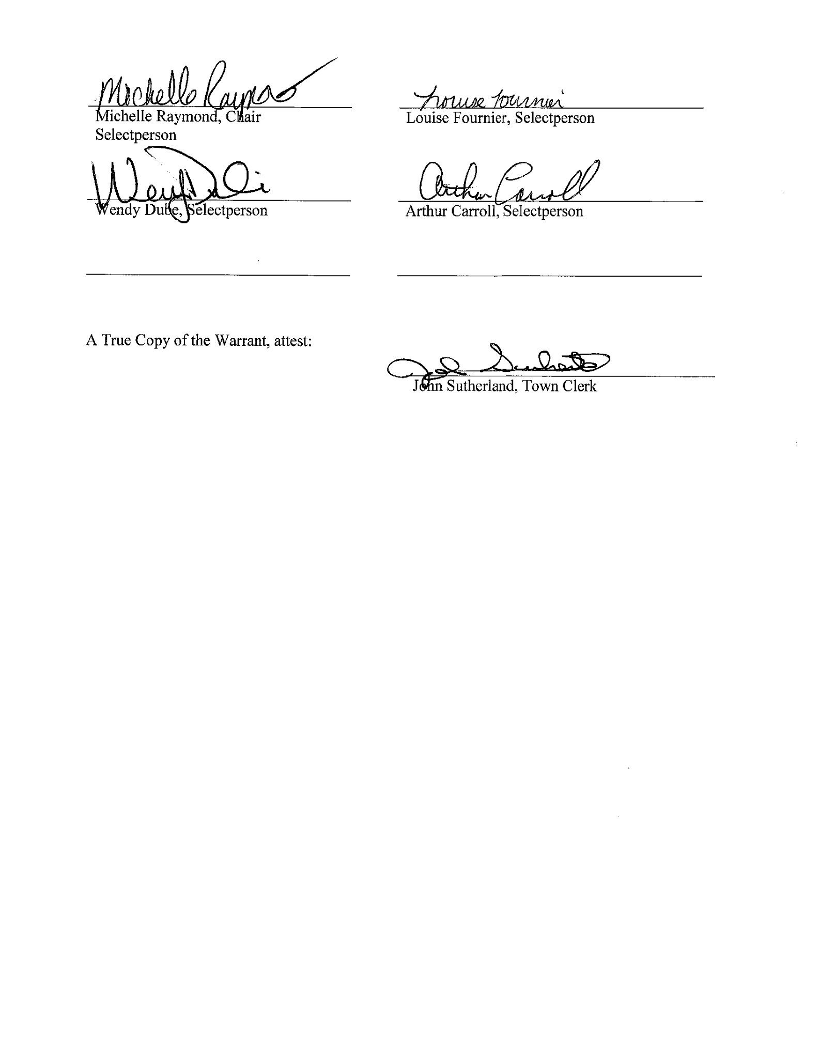
Signed at the Town Office of Eagle Lake on May 15, 2019 by a majority of the Selectmen of the Town of Eagle Lake

TREASURER’S

STATEMENT

The following is a summary of the Bonded Indebtedness of the Town of Eagle Lake as of
May 15, 2019:

Total Town Indebtedness:
Bonds Outstanding: $ 964,983.00
Interest to be paid on Outstanding Bonds: $ 418,598.09
Loans Outstanding (Devoe Brook Road) $ 34,065.81
Loans Outstanding (Dennis/Forest Street) $ 53,689.96
Loans Outstanding (Old Main Street) $ 80,000.00
Interest to be paid on Outstanding Road Loans $ 6,455.34
Fire Department Loan $ 44,757.10
Interest to be paid on outstanding Fire Department Loan $ 2,157.34

Total Debt Service on Outstanding Bonds & Loans: $ 1,604,706.64

Additional Loan to be issued (if approved by voters): $ 80,000.00
Paving Old Main Street from tracks forward
Estimated Interest (3.50% fixed rate for three years) on New Loan: $ 4,389.99
Total Est. Purchase Price: $ 84,389.99

Real Term Energy (3.75 Fixed Rate for 10 Years) $ 45,000.00
If approved by voters this will replace existing street
lights with energy efficient LEDs.
Interest on Loan $ 9,033.07
Total Est. Purchase Price: $ 54,033.07

Total Debt Service if Additional Loan is issued: $ 1,743,129.70

Page 50
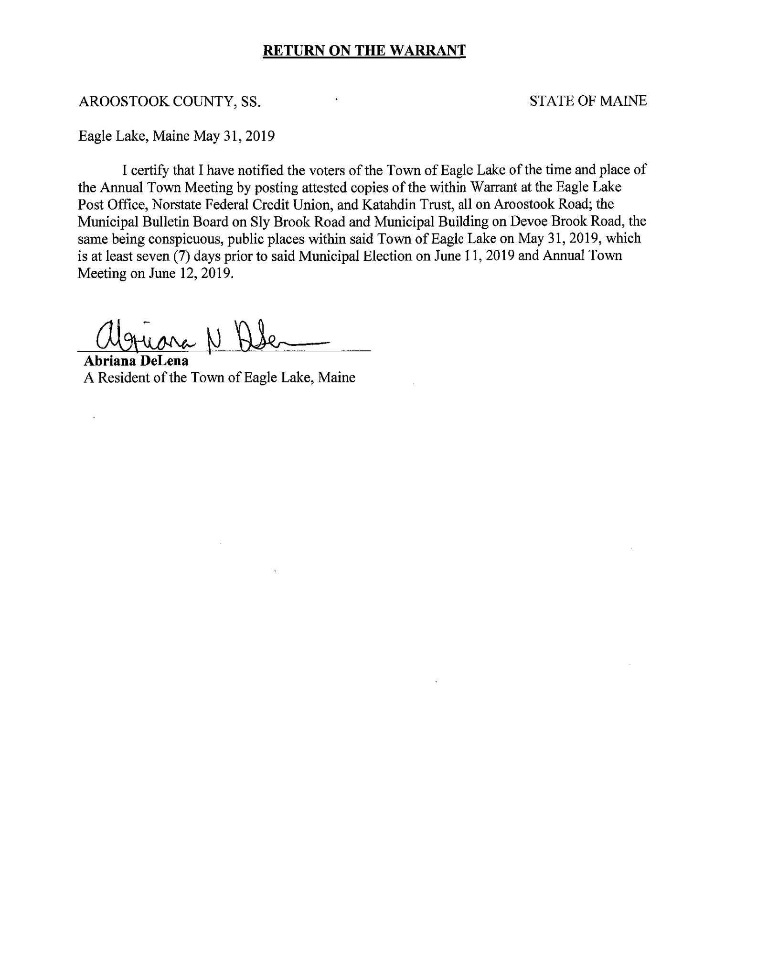
Page 51

TOWN OF EAGLE LAKE SERVICE DIRECTORY

Town of Eagle Lake | 444-5125
Eagle Lake Town Manager, John Sutherland | 444-5511
Fax Machine | 444-2810
Fire Department EMERGENCY ONLY | 911
Fire Department Information | 444-5234
Recreation Building | 444-5491
Ambulance Service EMERGENCY ONLY | 911
General Assistance Administrator, John Sutherland | 444-5511
Applications Monday thru Thursday from 8:00 AM-4:30 PM
Animal Control Officer, John Pelletier | 834-5259
Code Enforcement Officer, Andrew Dube (Madawaska Office) | 728-6351
Local Plumbing Inspector, Dennis Cyr | 231-1171
Constable, Cyr Martin | 444-4006
Maine State Police | 1-800-924-2261
Sheriff’s Department | 1-800-432-7842
BURNING PERMITS
Fire Chief, Rene St. Onge | 231-4729
Eagle Lake Water & Sewer District: | 444-5441
Northern Aroostook Solid Waste Association (Transfer Station) | 444-6246
Wednesday 6:00 PM to 8:00 PM (mid-May to mid-Oct) Saturday 8:00 AM to 5:00 PM ( All Year)
Fort Kent Community High School | 834-5540
MSAD 27 Superintendent’s Office | 834-3189
Fish River Rural Health Center | 444-5322
 | 444-5973

PAGE 52

